BIOTECTIVE User Manual

AI-Powered Healthcare Ecosystem - Patient Management System

Table of Contents
- Introduction
- Quick Start Guide
- Getting Started
- User Roles Overview
- Patient User Guide
- Doctor User Guide
- Admin User Guide
- Common Features
- Troubleshooting
- Glossary

Introduction

What does the system provide?
AI-powered healthcare ecosystem designed to help healthcare providers manage diabetic patients more effectively. The system combines patient management, AI-driven risk prediction, therapy effectiveness analysis, and treatment recommendations to provide comprehensive diabetes care.

Key Features
- Patient Management - Comprehensive patient records with clinical data tracking
- Risk Prediction - AI-powered HbA1c prediction using machine learning models
- Therapy Effectiveness - Analysis of treatment outcomes and patient progress
- Treatment Recommendations - AI-generated personalized treatment plans using RAG (Retrieval-Augmented Generation)
- Messaging System - Secure communication between doctors and patients
- Appointment Management - Schedule and track patient appointments
- Health Information Hub - Educational resources about diabetes, hypertension, and cardiovascular health

Quick Start Guide

Getting Started in 5 Minutes

For Patients
- Login → Enter your email and password
- View Dashboard → Learn about diabetes, hypertension, and healthy lifestyle
- Check Profile → Click “My Profile” to see your health metrics
- Chat with Bot → Ask health questions and get personalized answers
- Message Doctor → Click “Messages” to communicate with your doctor
Key Features:
- 📊 View your HbA1c, FVG, and DDS trends
- 🤖 AI chatbot for health questions
- 💬 Secure messaging with your doctor
- 📚 Educational health resources

For Doctors
- Login → Enter your credentials
- View Patients → Click “List of Patients” to see all assigned patients
- Add Patient → Hover over “List of Patients” and click “Add Patient”
- Run Predictions → Click risk prediction icon next to any patient
- Generate Reports → Use AI tools for therapy analysis and treatment recommendations
Key Features:
- 👥 Manage patient records
- 🔮 AI-powered HbA1c risk prediction
- 📈 Therapy effectiveness analysis
- 💊 AI-generated treatment recommendations
- 📅 Appointment scheduling
- 💬 Patient messaging
Quick Actions:
- Risk Prediction: Patient List → Click line chart icon
- Therapy Analysis: Patient Profile → Therapy Effectiveness tab
- Treatment Plan: Patient Profile → Treatment Recommendation tab

For Admins
- Login → Enter admin credentials
- Manage Users → Create doctors and patients
- Assign Patients → Link patients to their doctors
- Monitor System → View analytics and system health
Key Features:
- 👤 User management (create, edit, delete)
- 🔗 Patient-doctor assignment
- 📊 System analytics
- ⚙️ System configuration

Navigation Cheat Sheet
Sidebar Menu:
- Dashboard → Home page with health info
- Patients → Patient list (doctors only)
- Messages → Secure messaging
- Appointments → Schedule management (doctors)
- Risk Prediction → AI predictions (doctors)
- Therapy Effectiveness → Treatment analysis (doctors)
- Treatment Recommendation → AI treatment plans (doctors)
- Chatbot → AI health assistant (patients)
Top Bar:
- 🔔 Bell Icon → Notifications
- ⚙️ Gear Icon → Settings
- 👤 Profile Badge → Your role and name
- 🚪 Log Out → Bottom of sidebar

Common Tasks Quick Reference
Add a New Patient (Doctor):
- Hover over “List of Patients”
- Click “Add Patient” button
- Fill in patient information
- Click “Create Patient”
Predict Patient Risk (Doctor):
- Go to “List of Patients”
- Click line chart icon next to patient name
- View predicted HbA1c and risk level
- Review key factors
Generate Treatment Plan (Doctor):
- Open patient profile
- Click “Treatment Recommendation”
- Click “Generate Report”
- Review AI-generated plan
- Use chat to ask follow-up questions
Message Your Doctor (Patient):
- Click “Messages” in sidebar
- Type your message
- Click “Send”
- Wait for doctor’s response
Assign Patient to Doctor (Admin):
- Click “Manage Patients”
- Click “+ Assign Patient ↔ Doctor”
- Select patient and doctor
- Click “Assign”

Understanding Your Metrics
HbA1c (Hemoglobin A1c):
- Normal: <5.7%
- Prediabetes: 5.7-6.4%
- Diabetes: ≥6.5%
- Target for diabetics: <7%
FVG (Fasting Venous Glucose):
- Normal: <5.6 mmol/L
- Prediabetes: 5.6-6.9 mmol/L
- Diabetes: ≥7.0 mmol/L
DDS (Diabetes Distress Scale):
- Low distress: <2.0
- Moderate distress: 2.0-2.9
- High distress: ≥3.0
BMI (Body Mass Index):
- Underweight: <18.5
- Normal: 18.5-24.9
- Overweight: 25-29.9
- Obese: ≥30

Status Colors
Patient Status:
- 🟢 Green (Improving) → HbA1c dropping, good progress
- 🟡 Yellow (Stable) → Minimal changes, maintaining
- 🔴 Red (Worsening) → HbA1c rising, needs attention
Risk Levels:
- 🟢 Normal → <5.7%
- 🟡 At Risk → 5.7-6.4%
- 🟠 Moderate → 6.5-7.0%
- 🔴 Risky → 7.1-8.0%
- 🔴 Very Risky → 8.1-9.0%
- ⚫ Critical → >9.0%

Getting Started

System Requirements
- Web Browser: Chrome, Firefox, Safari, or Edge (latest versions)
- Internet Connection: Stable internet connection required
- Screen Resolution: Minimum 1280x720 recommended

Accessing the System
📸 SCREENSHOT 1: Login Page
Show: Full login page with email/password fields, ‘Sign in’ button, ‘Remember me’ checkbox, and ‘Sign up’ link
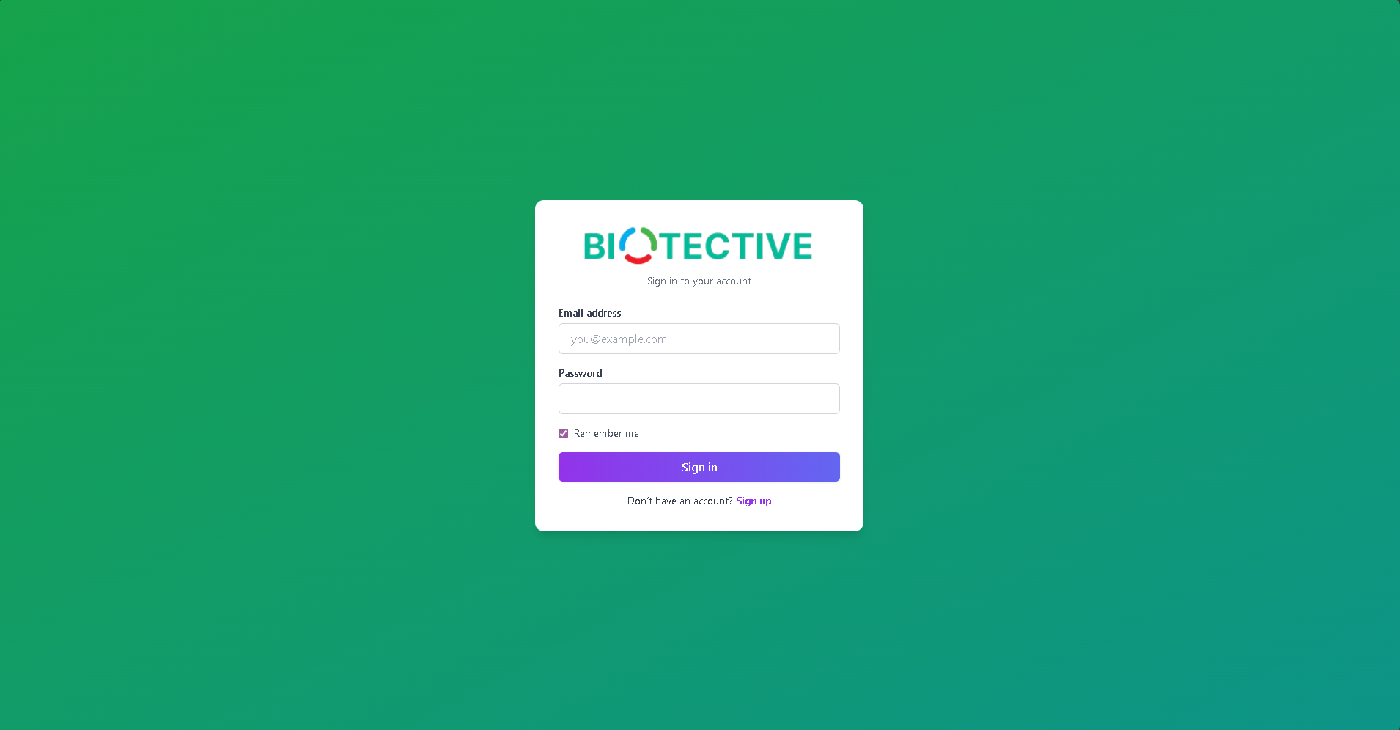
- Open your web browser
- Navigate to the BIOTECTIVE application URL
- You will be directed to the Sign In page

First-Time Login
- Enter your email address and password
- Check the “Remember me” box if you want to stay logged in
- Click Sign in
- If you don’t have an account, click Sign up to register

Registration (New Users)
📸 SCREENSHOT 2: Registration Page
Show: Registration form with all fields, role selection dropdown, and ‘Register’ button
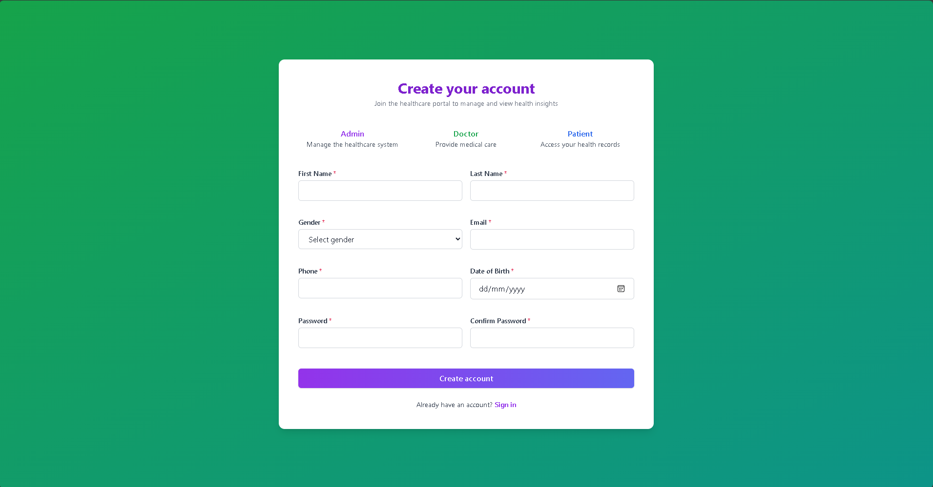
- Click Sign up on the login page
- Fill in the registration form:
  - Full Name
  - Email Address
  - Password (minimum 8 characters)
  - Confirm Password
  - Select your role (Patient/Doctor)
- Click Register
- You will be redirected to the login page

User Roles Overview
BIOTECTIVE has three distinct user roles, each with specific permissions and features:

1. Patient
- View personal health profile
- Access health metrics and trends
- Chat with AI health assistant
- Message assigned doctor
- View educational health information

2. Doctor
- Manage patient list
- Create and update patient records
- Perform risk predictions
- Analyze therapy effectiveness
- Generate treatment recommendations
- Schedule appointments
- Message patients
- Access all AI-powered tools

3. Admin
- Manage all users (create, edit, delete)
- Manage all patients
- Assign patients to doctors
- View system analytics
- Access administrative settings

Patient User Guide

Dashboard
When you log in as a patient
📸 SCREENSHOT 3: Patient Dashboard
Show: Health Information Hub with all 4 tabs visible (Diabetes, Hypertension, Cardiovascular, Healthy Lifestyle)
, you’ll see the Health Information Hub dashboard with educational content about:
- Diabetes - Types, management, monitoring, medication, diet, and physical activity
- Hypertension - Blood pressure management, dietary approaches, medications, lifestyle modifications
- Cardiovascular Disease - Heart health, diet, exercise, risk factor management
- Healthy Lifestyle - Nutrition guidelines, physical activity, stress management, sleep hygiene
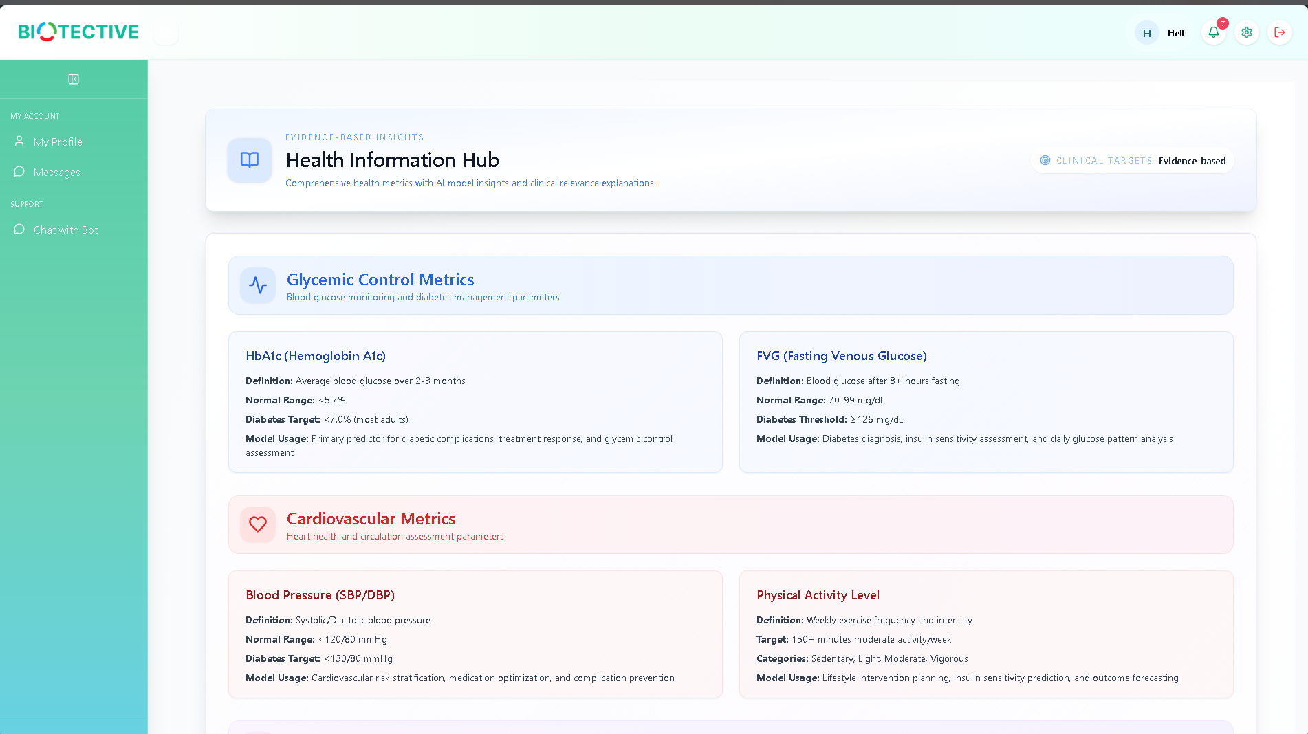
How to Use:
- Click on the tabs at the top to switch between health topics
- Read through the sections to learn about your condition
- Follow the recommendations provided by your healthcare team

My Profile
Access your personal health profile
📸 SCREENSHOT 5: Patient Profile Page
Show: Complete patient profile with personal info, clinical measurements, and treatment information
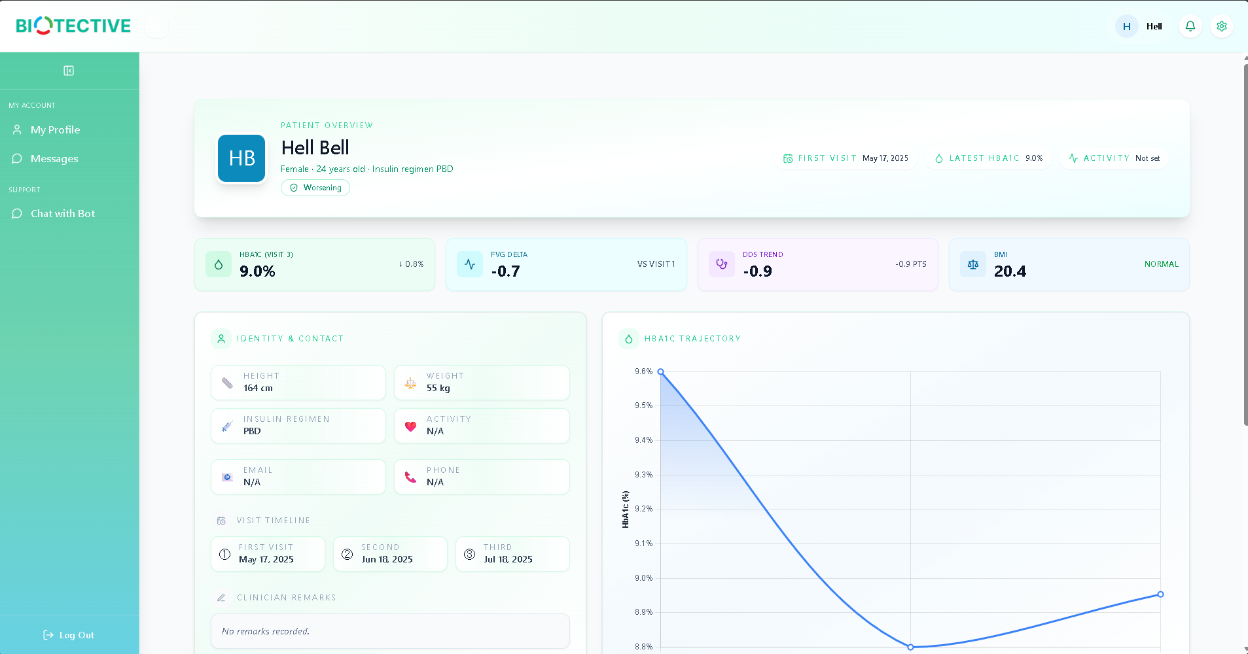
📸 SCREENSHOT 6: Patient Metrics Close-up
Show: Zoomed view of key metrics (HbA1c, FVG, DDS, BMI) with values
to view your medical information.
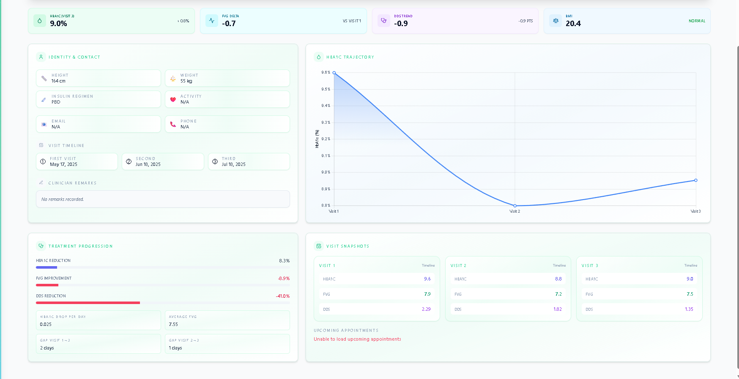

Steps:
- Click My Profile in the sidebar
- View your health metrics:
  - Personal information (name, age, gender, ethnicity)
  - Clinical measurements (HbA1c, FVG, DDS, BMI)
  - Insulin regimen
  - Visit history
  - Medical history and medications
Key Metrics Explained:
- HbA1c (%) - Average blood glucose over 2-3 months (target: <7%)
- FVG (mmol/L) - Fasting venous glucose levels
- DDS - Diabetes Distress Scale (measures emotional burden)
- BMI - Body Mass Index (weight/height ratio)
- eGFR - Kidney function indicator
- UACR - Urine albumin-to-creatinine ratio (kidney health)

Chat with Bot
Get instant answers
📸 SCREENSHOT 7: AI Chatbot Interface
Show: Full chatbot page with metrics display, HbA1c chart, and chat interface
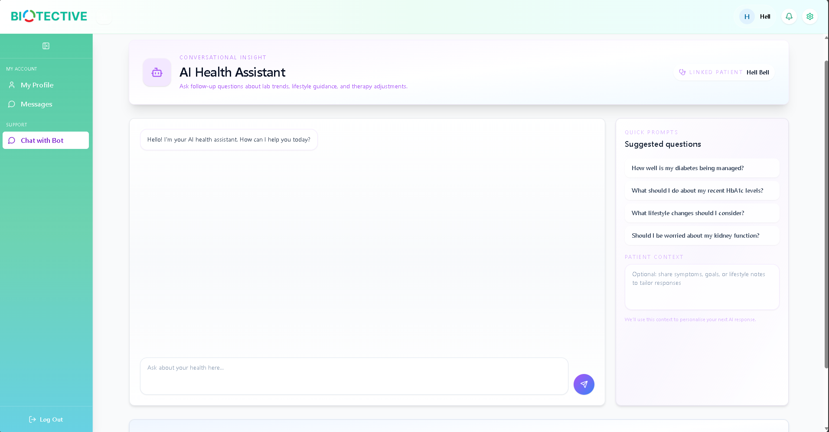
📸 SCREENSHOT 8: Chatbot Conversation Example
Show: Sample Q&A exchange between patient and AI
to your health questions using the AI chatbot.
*cannot call chatbot*

Steps:
- Click Chat with Bot in the sidebar
- View your current health metrics displayed at the top
- Review the HbA1c trend chart showing your progress
- Type your question in the chat box at the bottom
- Click Send or press Enter
- The AI will respond with personalized information based on your health data
Example Questions:
- “What should my target HbA1c be?”
- “How can I improve my blood sugar control?”
- “What foods should I avoid?”
- “Why is my DDS score important?”
Tips:
- Be specific in your questions
- The chatbot uses your actual patient data for personalized responses
- Responses are based on medical literature and guidelines
- Always consult your doctor for medical decisions

Messages
Communicate securely
📸 SCREENSHOT 9: Patient Messages Page
Show: Message thread with doctor, conversation history and input box
with your assigned doctor.
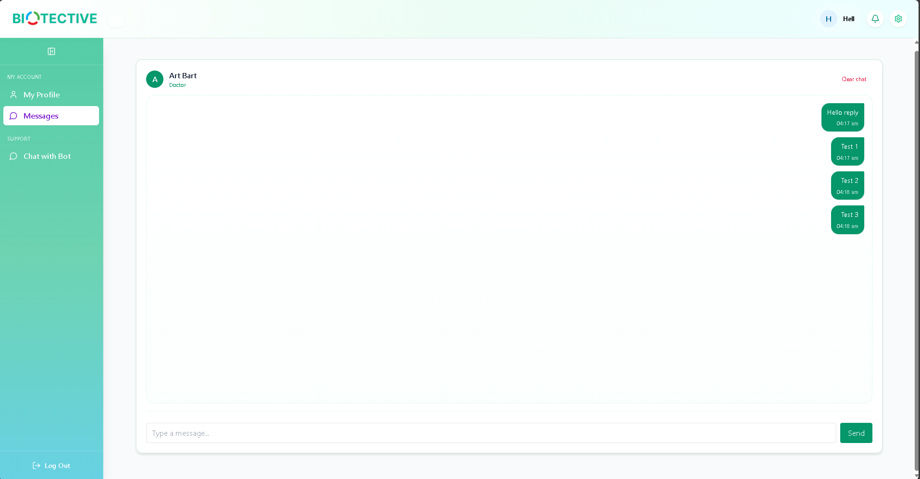
Steps:
- Click Messages in the sidebar
- View your conversation thread with your doctor
- Type your message in the text box at the bottom
- Click Send to deliver your message
- You’ll receive notifications when your doctor replies
Best Practices:
- Be clear and concise in your messages
- Include relevant symptoms or concerns
- Don’t use messaging for emergencies (call 911 instead)
- Check messages regularly for doctor responses

Settings
Manage your account preferences
📸 SCREENSHOT 10: Patient Settings
Show: Settings page with profile fields and ‘Save Changes’ button
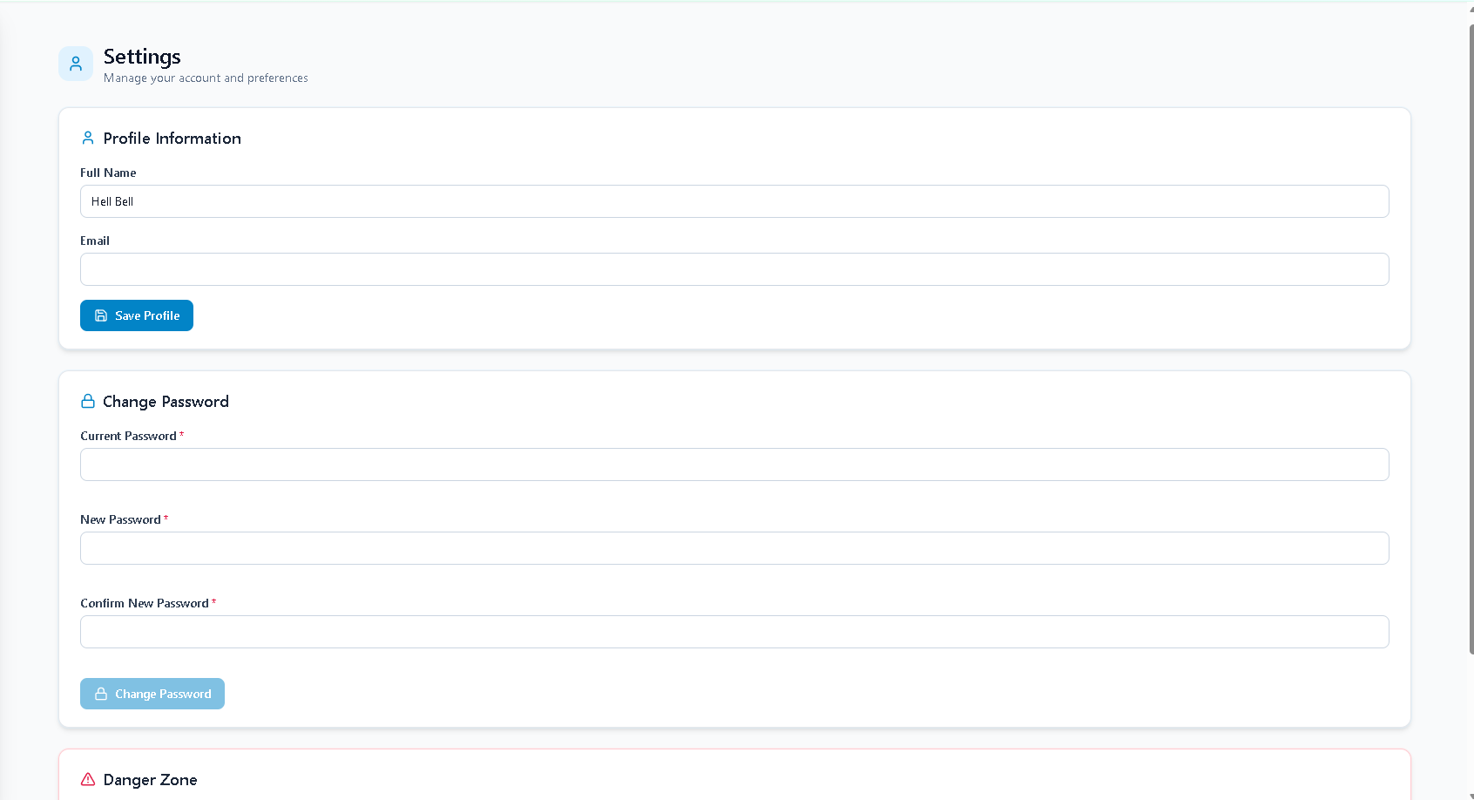
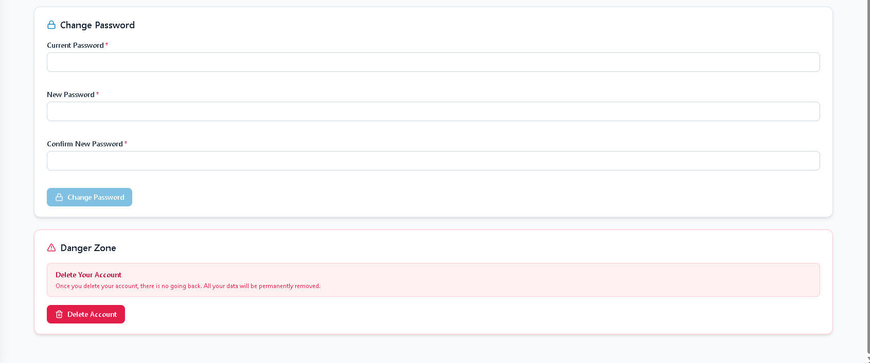
Steps:
- Click the Settings icon (gear) in the top-right corner
- Update your profile information
- Change your password
- Adjust notification preferences
- Click Save Changes

Doctor User Guide

Dashboard
📸 SCREENSHOT 11: Doctor Dashboard
Show: Doctor’s main dashboard with summary statistics and sidebar
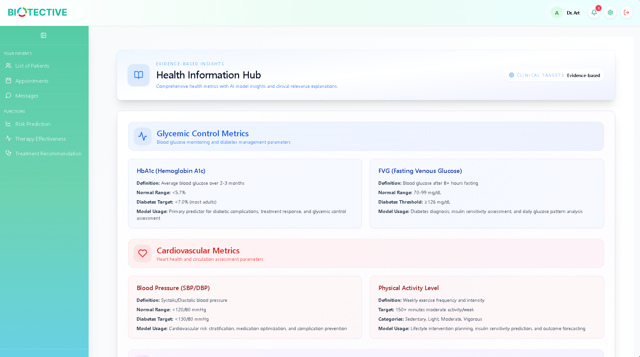
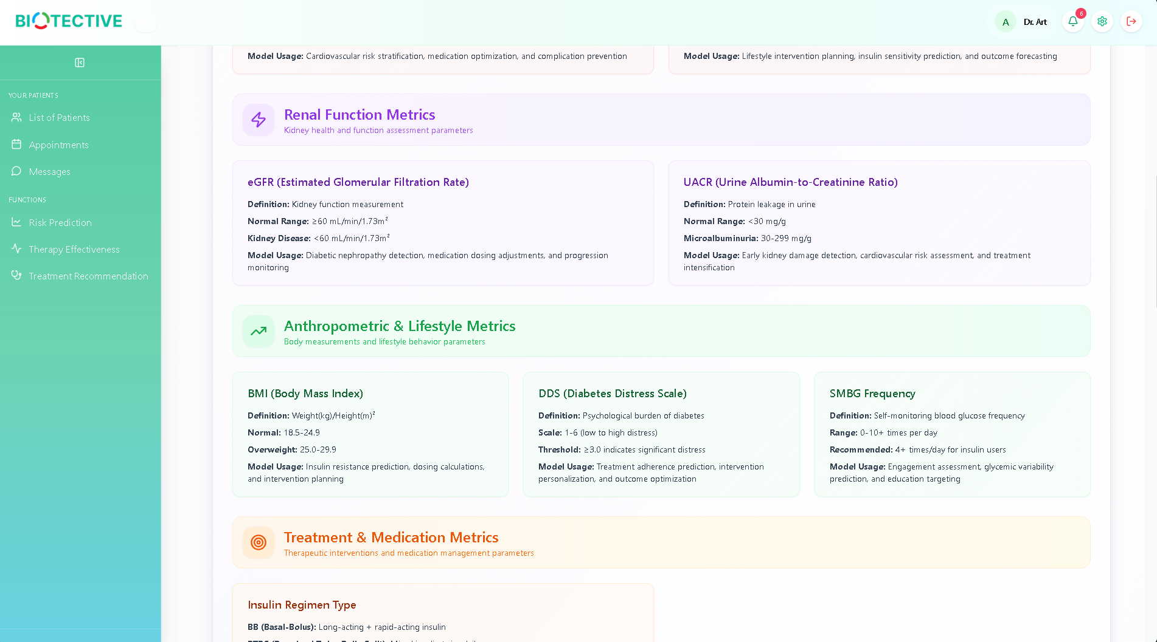
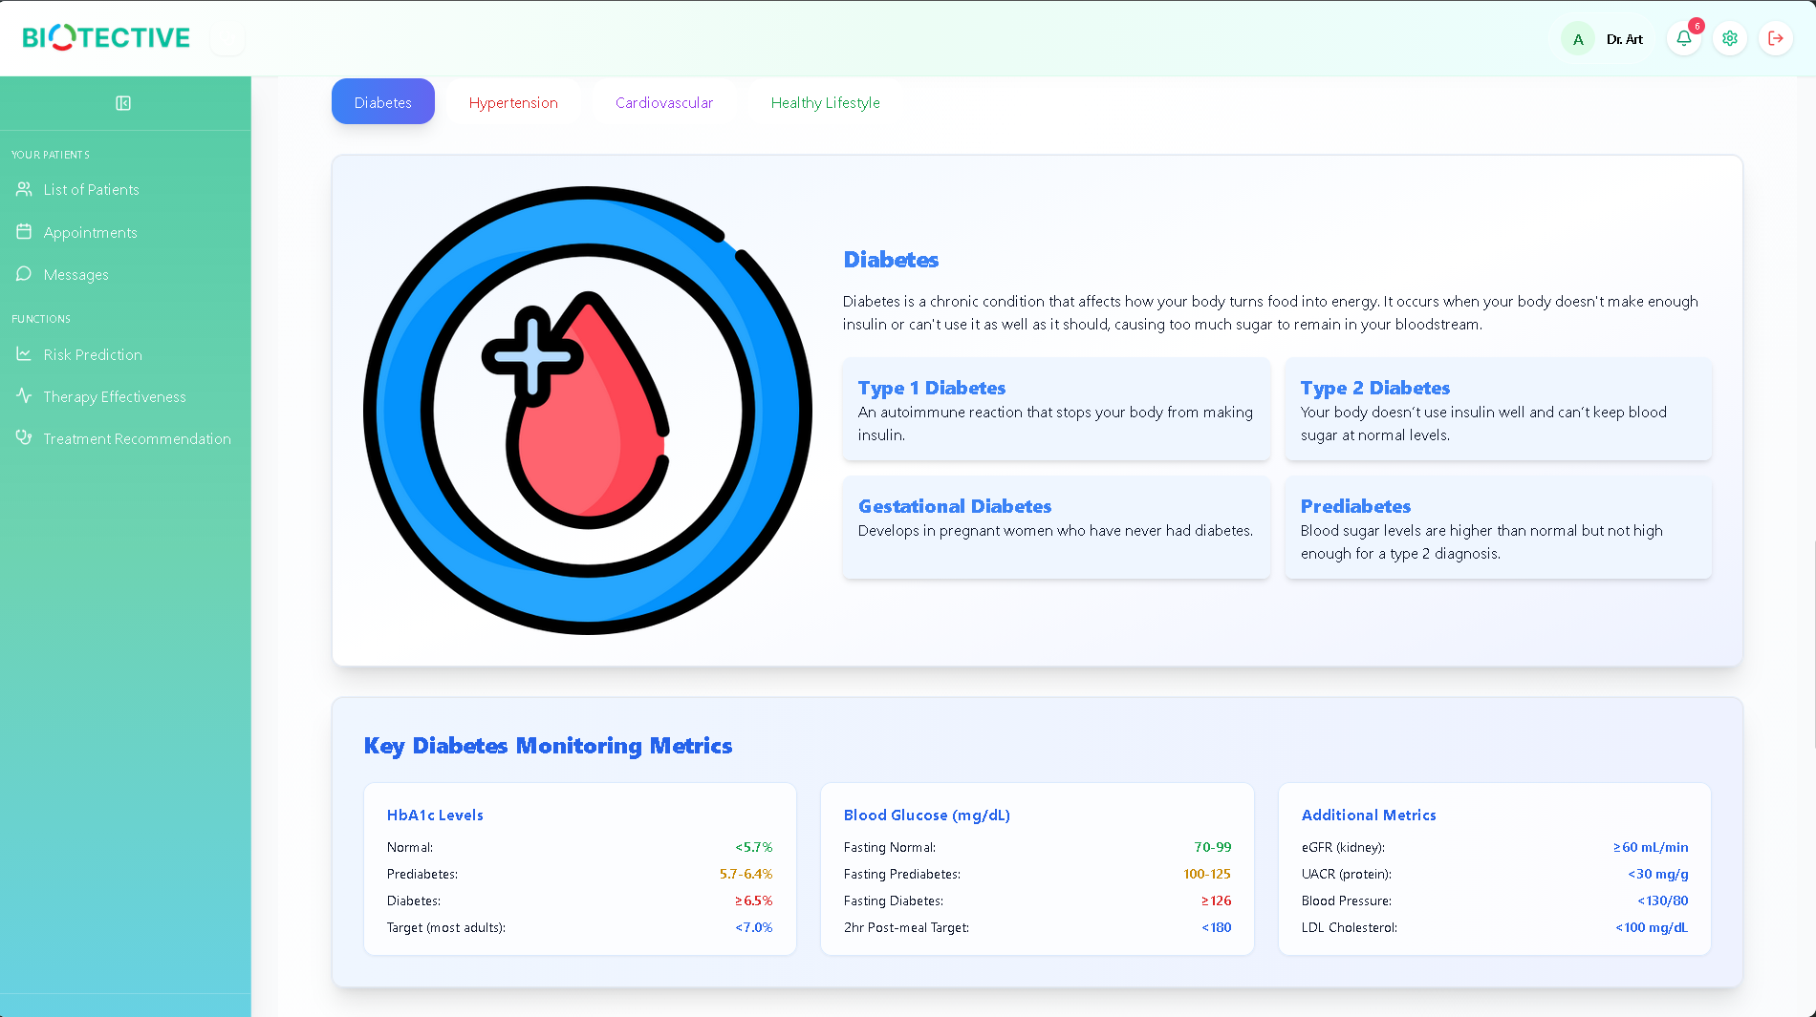
The doctor dashboard provides an overview of your practice and quick access to key features.
Features:
- Summary statistics (total patients, improving, stable, worsening)
- Quick access to patient management tools
- Recent activity and notifications

List of Patients
View and manage all patients
📸 SCREENSHOT 12: Patient List View
Show: Full patient list table with search, filters, and action buttons
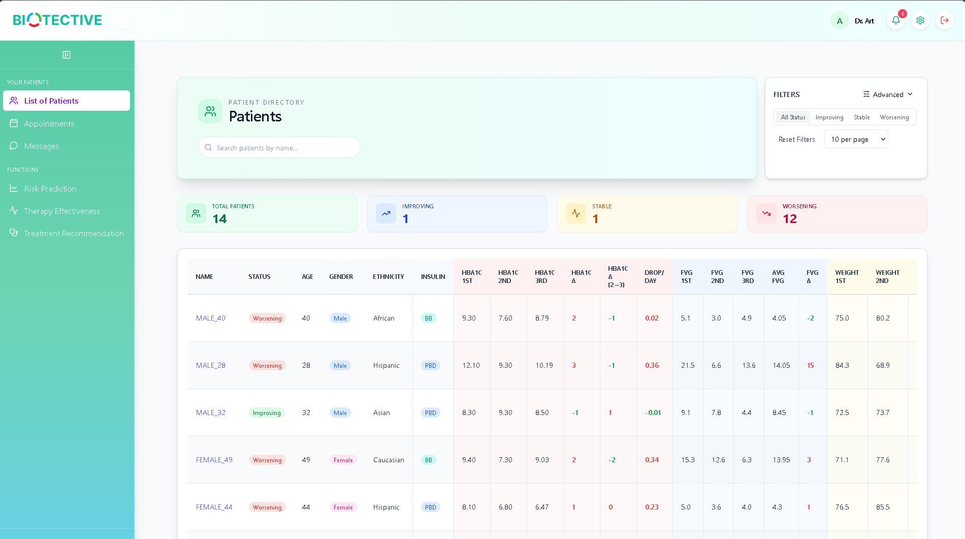
📸 SCREENSHOT 13: Patient List Filters
Show: Filter panel with all options expanded
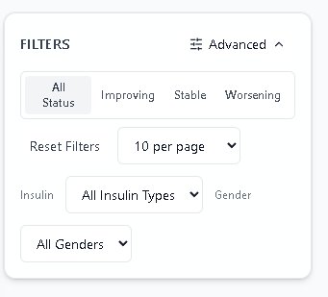

Steps:
- Click List of Patients in the sidebar
- Use the search bar to find specific patients by name
- Apply filters:
  - Status Filter: All Status, Improving, Stable, Worsening
  - Insulin Type: Basal, Bolus, PBD, BB, PTDS, None
  - Gender: Male, Female
- Click Advanced to access additional filters
- Adjust items per page (10, 25, 50, 100)
Patient Table Columns:
- Name - Click to view full profile
- Age, Gender - Demographics
- Insulin - Current insulin regimen
- FVG - Fasting venous glucose
- HbA1c (1st, 2nd, 3rd) - Values across visits
- Avg FVG - Average fasting glucose
- FVG Δ - Change in FVG (green=improving, red=worsening)
- HbA1c Δ - Change in HbA1c
- Drop/Day - Daily HbA1c reduction rate
- DDS Δ - Change in diabetes distress
- Gap - Days between visits
- Status - Overall patient status
- Actions - View, Risk Prediction buttons
Status Indicators:
- Improving - HbA1c drop >1.0% or FVG drop >1.0
- Stable - Minimal changes in metrics
- Worsening - HbA1c increase or FVG increase >1.0

Add Patient
Create new patient records
📸 SCREENSHOT 15: Add Patient Button
Show: Hover state showing ‘Add Patient’ button
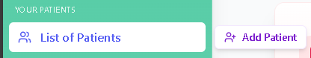
📸 SCREENSHOT 16: Create Patient Form - Personal Info
Show: Personal information section with all fields
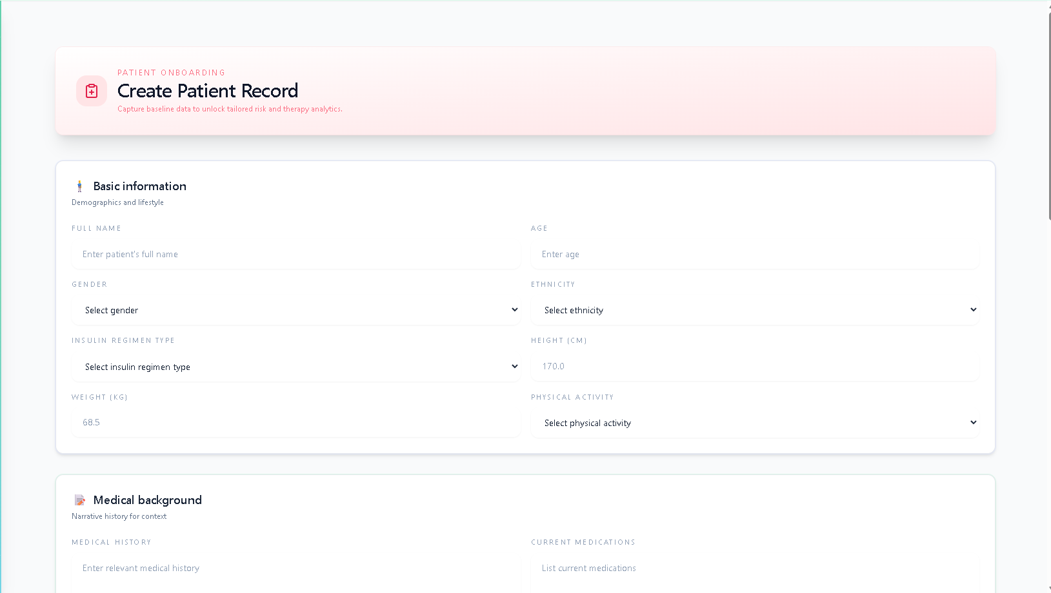
📸 SCREENSHOT 17: Create Patient Form - Clinical Data
Show: Visit 1, 2, 3 data sections
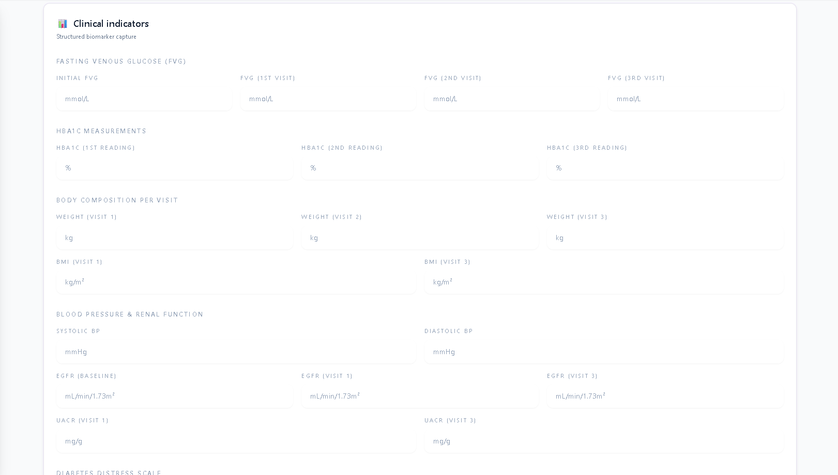
📸 SCREENSHOT 18: Create Patient Form - Treatment
Show: Treatment section with insulin dropdown and medications
in the system.
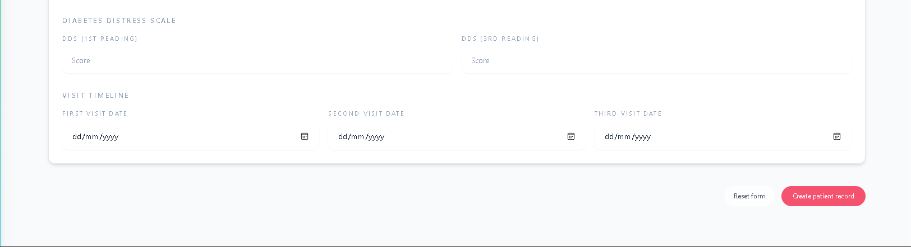
Steps:
- Hover over List of Patients in the sidebar
- Click Add Patient button that appears
- Fill in the patient information form:
Section 1: Personal Information
- Name (required)
- Age (required)
- Gender (Male/Female)
- Ethnicity (Caucasian, African, Hispanic, Asian, etc.)
- Height (cm)
- Weight (kg)
Section 2: Clinical Measurements
- Visit 1 Data:
  - HbA1c (%)
  - FVG (mmol/L)
  - Weight (kg)
  - BMI
  - DDS score
  - eGFR
  - UACR
  - Visit date
- Visit 2 Data:
  - HbA1c (%)
  - FVG (mmol/L)
  - Weight (kg)
  - Visit date
- Visit 3 Data:
  - HbA1c (%)
  - FVG (mmol/L)
  - Weight (kg)
  - BMI
  - DDS score
  - eGFR
  - UACR
  - Visit date
Section 3: Treatment Information
- Insulin Type (Basal, Bolus, PBD, BB, PTDS, None)
- Blood Pressure (SBP/DBP)
- Physical Activity level
- Medical History
- Current Medications
- Additional Remarks
- Click Create Patient to save
- The patient will be automatically assigned to you
Tips:
- Complete as many fields as possible for accurate AI predictions
- Visit dates help track patient progress over time
- Use the Remarks field for important notes

Patient Profile
View comprehensive patient information
📸 SCREENSHOT 19: Patient Profile Overview
Show: Patient profile with tabs and action buttons
and access AI tools.
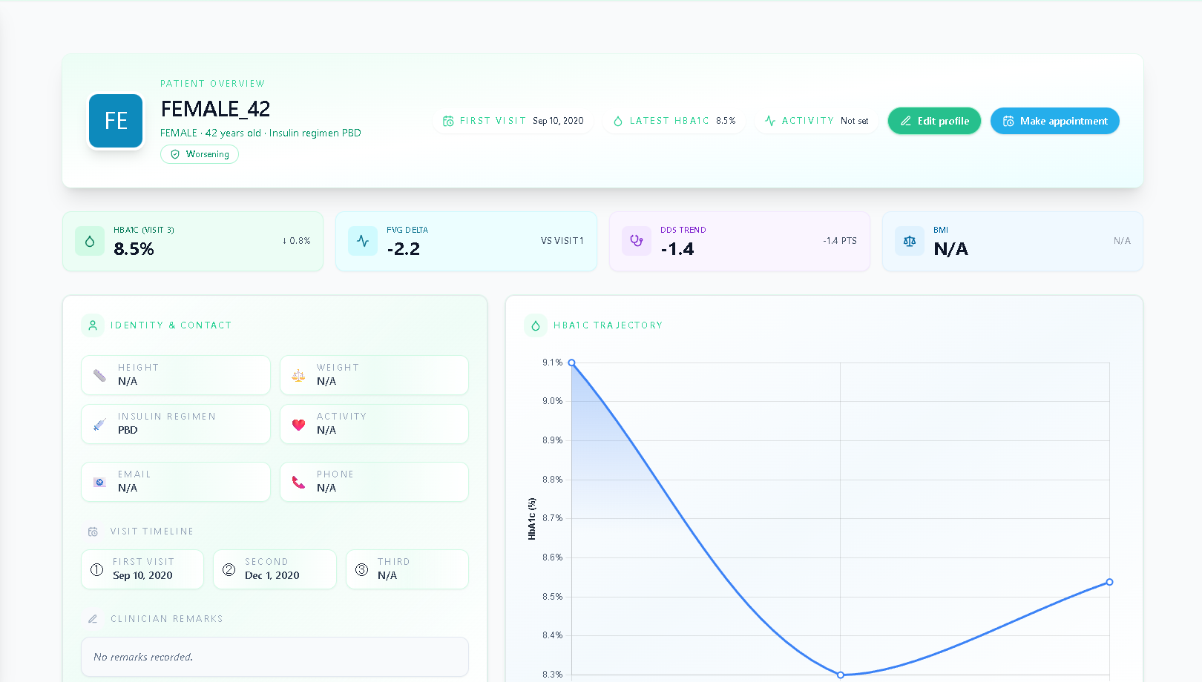
Steps:
- Click on a patient name from the patient list
- Navigate through tabs:
  - Overview - Summary of key metrics
  - Clinical Data - Detailed measurements
  - History - Visit timeline
  - Documents - Uploaded files
Available Actions:
- Edit Profile - Update patient information
- Risk Prediction - Predict future HbA1c
- Therapy Effectiveness - Analyze treatment outcomes
- Treatment Recommendation - Generate AI treatment plan
- Send Message - Communicate with patient

Risk Prediction
Predict patient’s future HbA1c
📸 SCREENSHOT 20: Risk Prediction Results
Show: Prediction page with HbA1c value, risk label, key factors
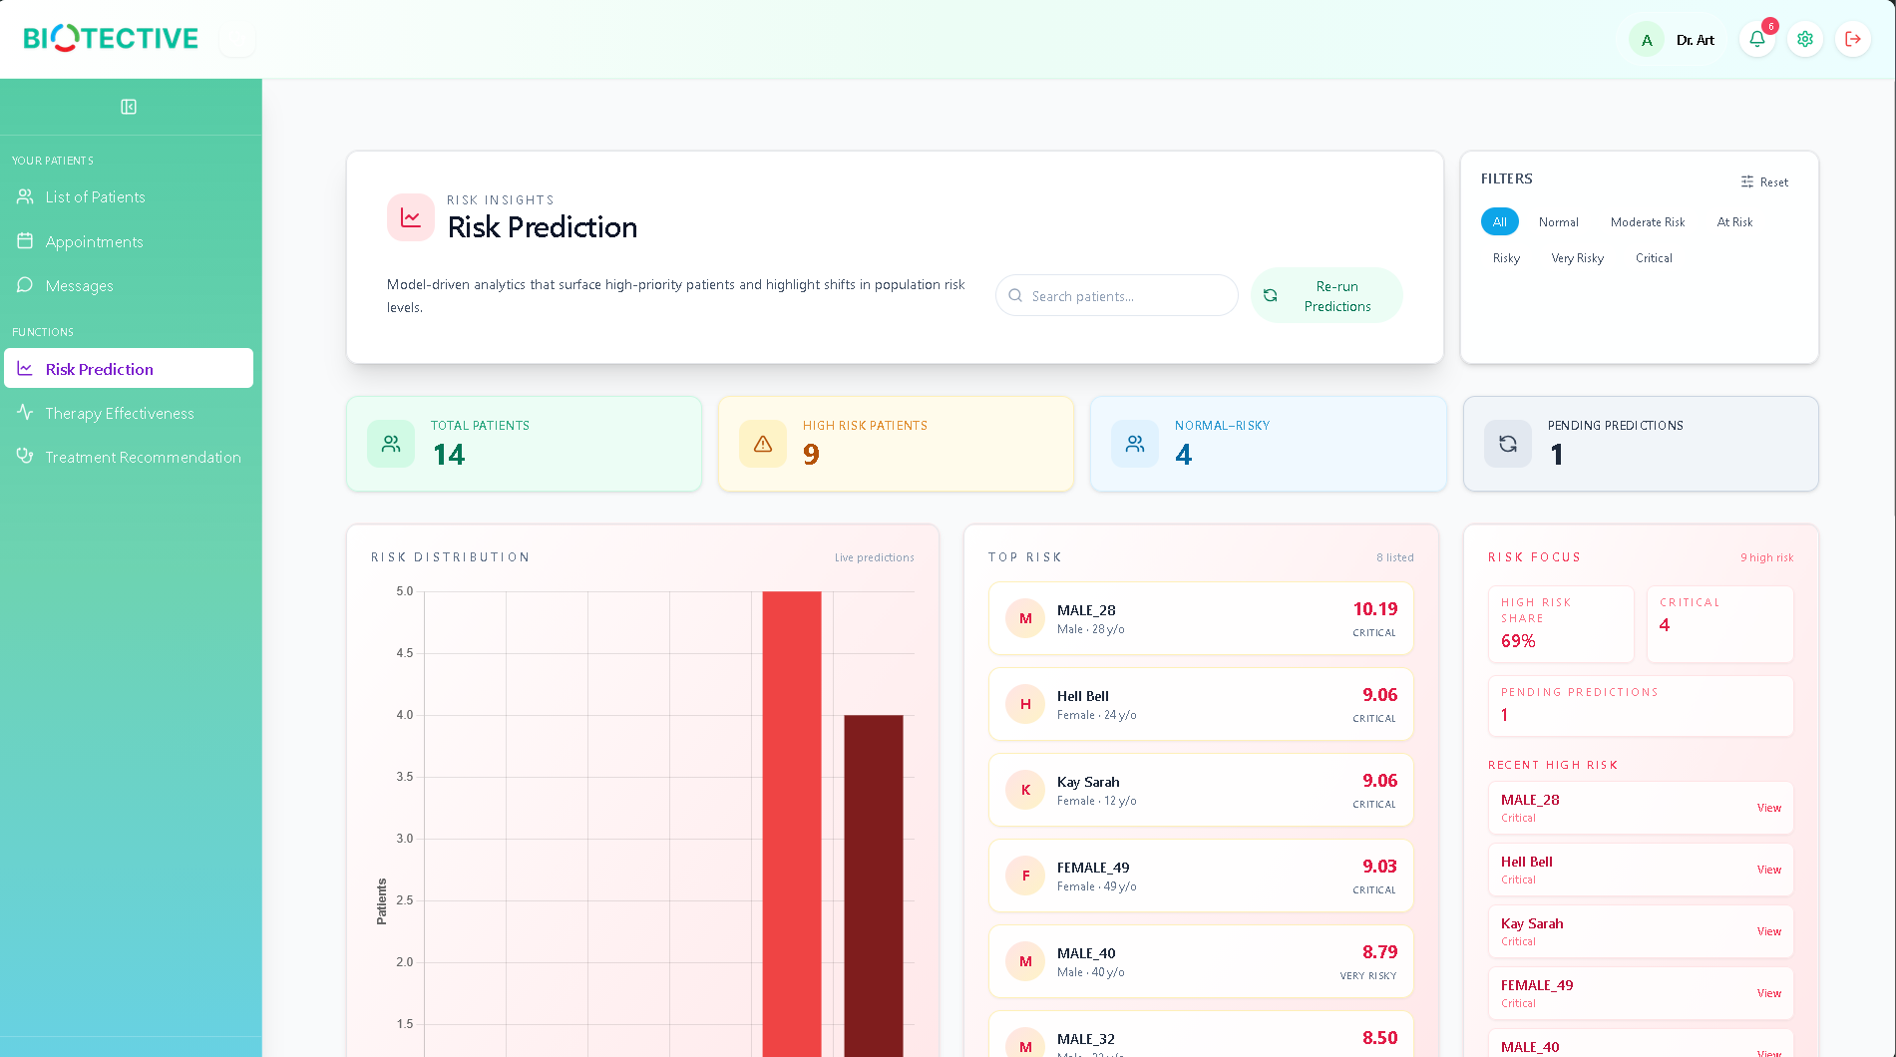
📸 SCREENSHOT 21: Risk Level Color Indicators
Show: All 6 risk levels with color legend
levels using AI.
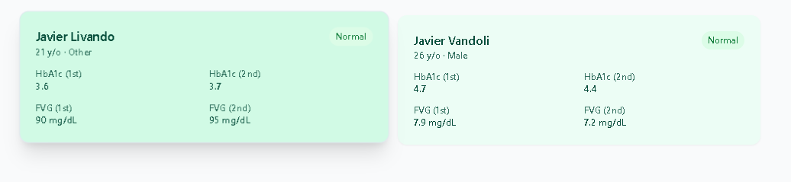
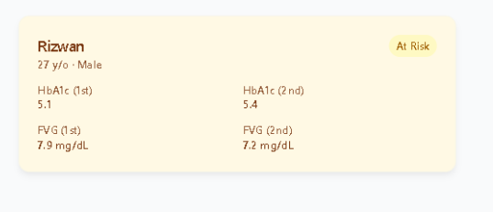
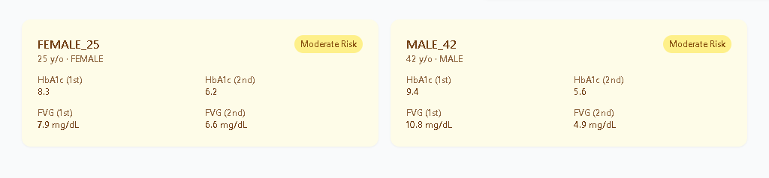
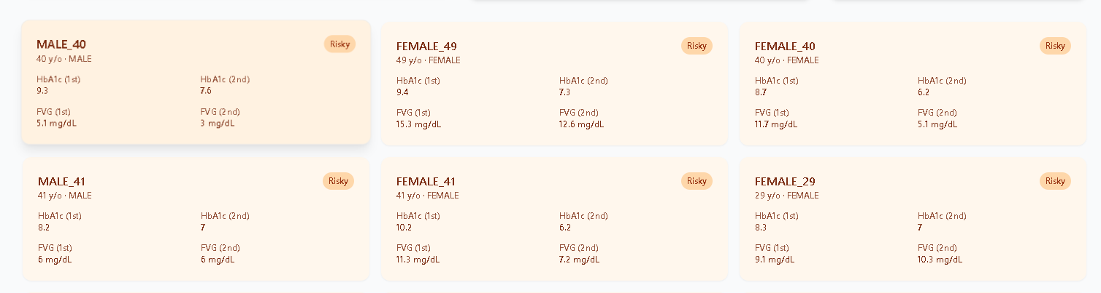
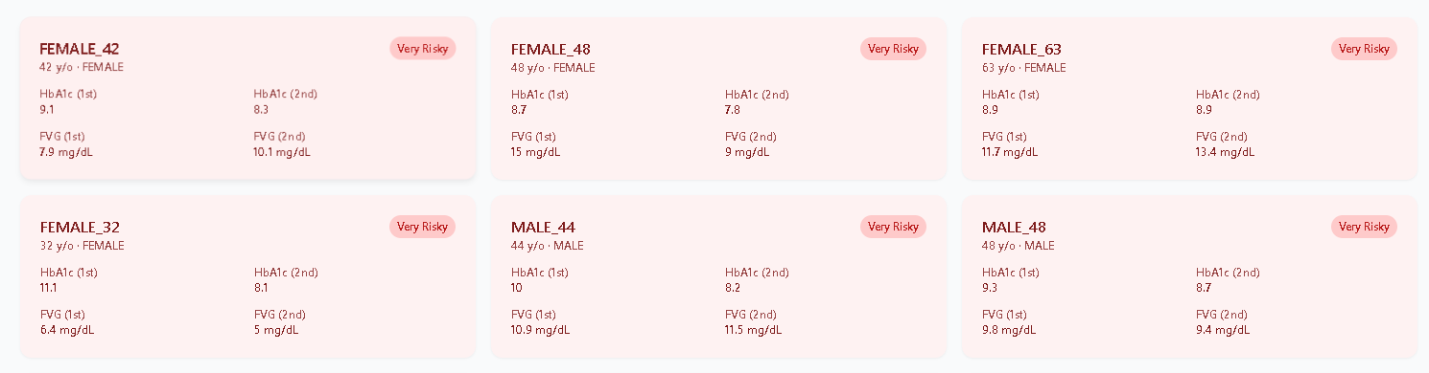
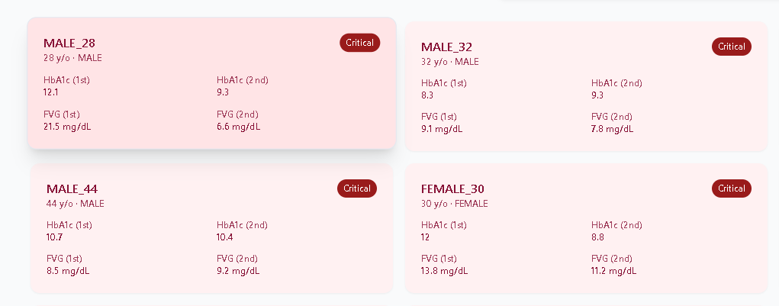
Steps:
- From patient list, click the Risk Prediction icon (line chart)
- Or navigate to Risk Prediction from sidebar, then select patient
- The system automatically calculates risk based on:
  - HbA1c values (visits 1 & 2)
  - FVG values (visits 1 & 2)
  - Average FVG
  - HbA1c reduction rate
Understanding Results:
- Predicted HbA1c - Estimated value for next visit
- Risk Label:
  - 🟢 Normal (<5.7%) - No diabetes
  - 🟡 At Risk (5.7-6.4%) - Prediabetes
  - 🟠 Moderate Risk (6.5-7.0%) - Controlled diabetes
  - 🔴 Risky (7.1-8.0%) - Poorly controlled
  - 🔴 Very Risky (8.1-9.0%) - Very poorly controlled
  - ⚫ Critical (>9.0%) - Immediate intervention needed
- Key Factors - Contributing factors to the prediction
- Last Updated - When prediction was calculated
Actions:
- Click Recalculate to force a fresh prediction
- Results are cached for performance
- Share results with patient during consultations

Therapy Effectiveness
Analyze how well the current treatment
📸 SCREENSHOT 22: Therapy Effectiveness Page
Show: Full analysis page with score, probability, chart, summary
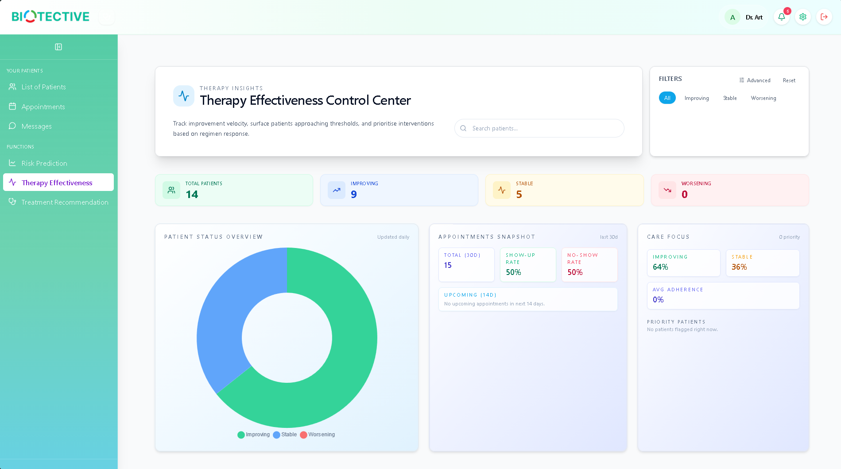
📸 SCREENSHOT 23: HbA1c Trajectory Chart
Show: Line chart with actual and forecasted values
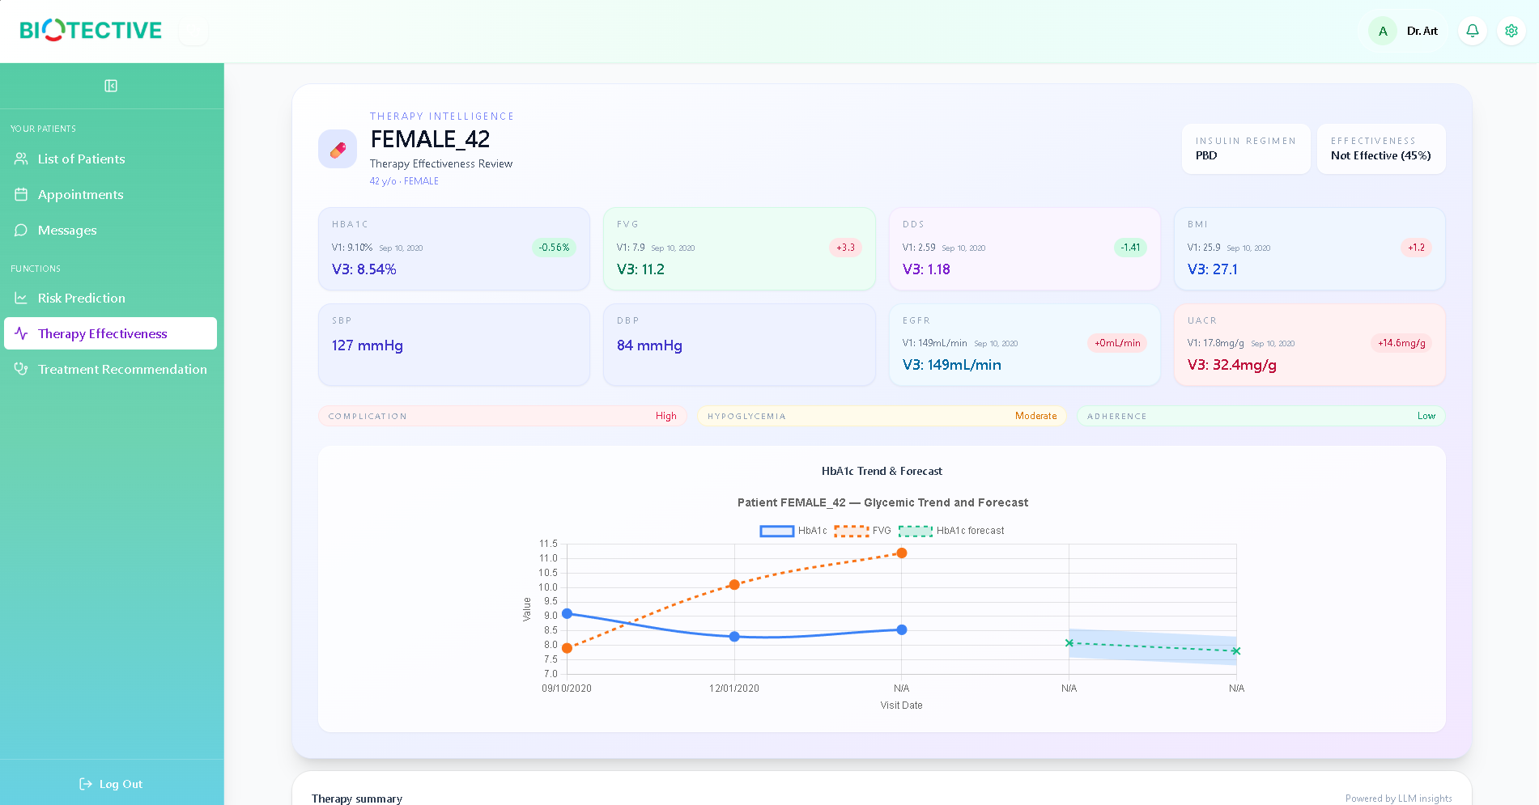

📸 SCREENSHOT 24: Effectiveness Score Breakdown
Show: Component breakdown with percentages
is working.
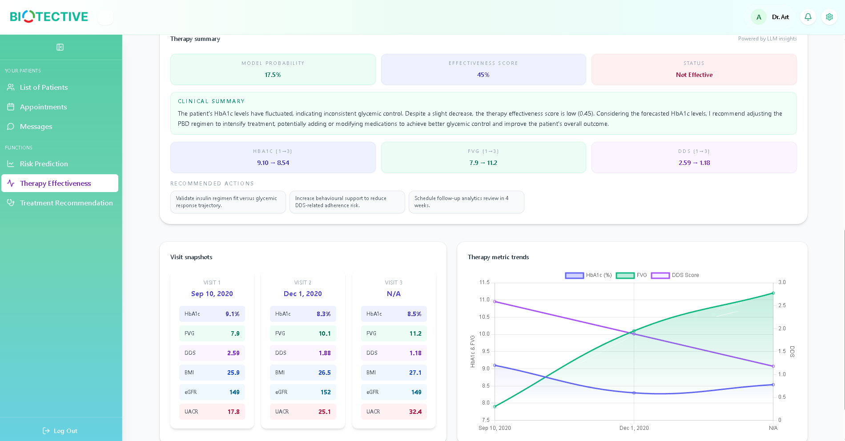
Steps:
- From patient profile, click Therapy Effectiveness
- Or navigate to Therapy Effectiveness from sidebar
- Select a patient from the dropdown
- Click Analyze Therapy
Analysis Components:
1. Effectiveness Score (0-100%)
- Calculated from multiple health metrics
- Weighted components:
  - HbA1c improvement (30%)
  - FVG improvement (20%)
  - BMI improvement (10%)
  - Blood pressure (10%)
  - Kidney function (20%)
  - Diabetes distress (10%)
2. Model Probability
- Machine learning prediction of therapy success
- Based on patient characteristics and treatment response
3. HbA1c Trajectory Chart
- Visual representation of HbA1c trends
- Shows actual values and forecasted future values
- Helps identify improvement or deterioration patterns
4. AI Summary
- Natural language explanation of results
- Clinical recommendations
- Suggested adjustments to treatment plan
Interpretation:
- Effective (≥50%) - Treatment is working well
- Not Effective (<50%) - Consider treatment modifications
Required Data:
- At least 3 visits with HbA1c, FVG, and DDS measurements
- BMI, blood pressure, kidney function data
- Complete demographic information

Treatment Recommendation
Generate AI-powered personalized
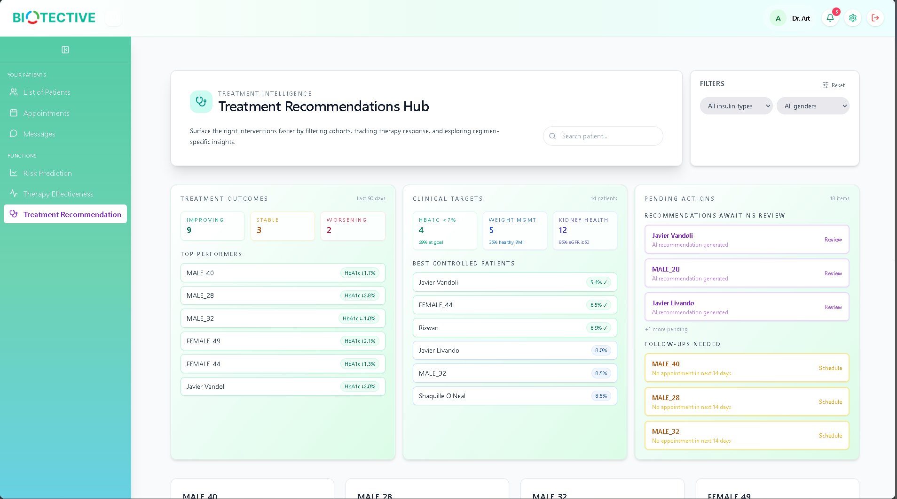
📸 SCREENSHOT 26: Clinical Trend Analysis Section
Show: Section 1 with HbA1c and FVG trends
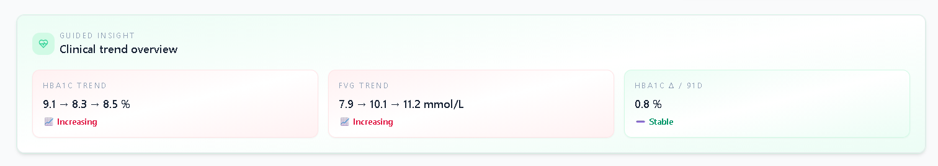
📸 SCREENSHOT 27: Risk Interpretation Section
Show: Section 2 with three risk bullets
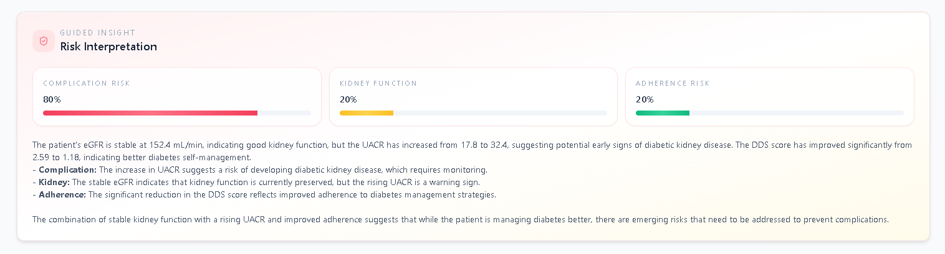
📸 SCREENSHOT 28: Medication Plan Section
Show: Section 3 with regimen review and adjustments
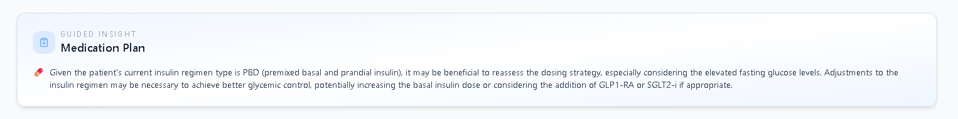
📸 SCREENSHOT 29: Lifestyle & Diet Section
Show: Section 4 with lifestyle and diet subsections
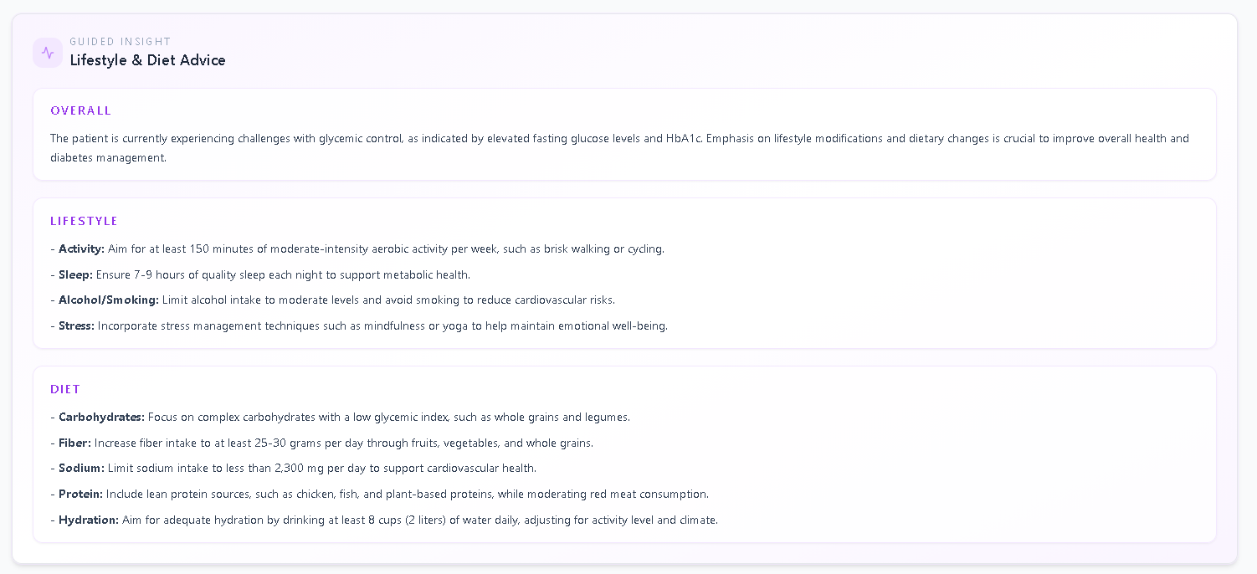
📸 SCREENSHOT 30: Treatment Chat Interface
Show: Chat box
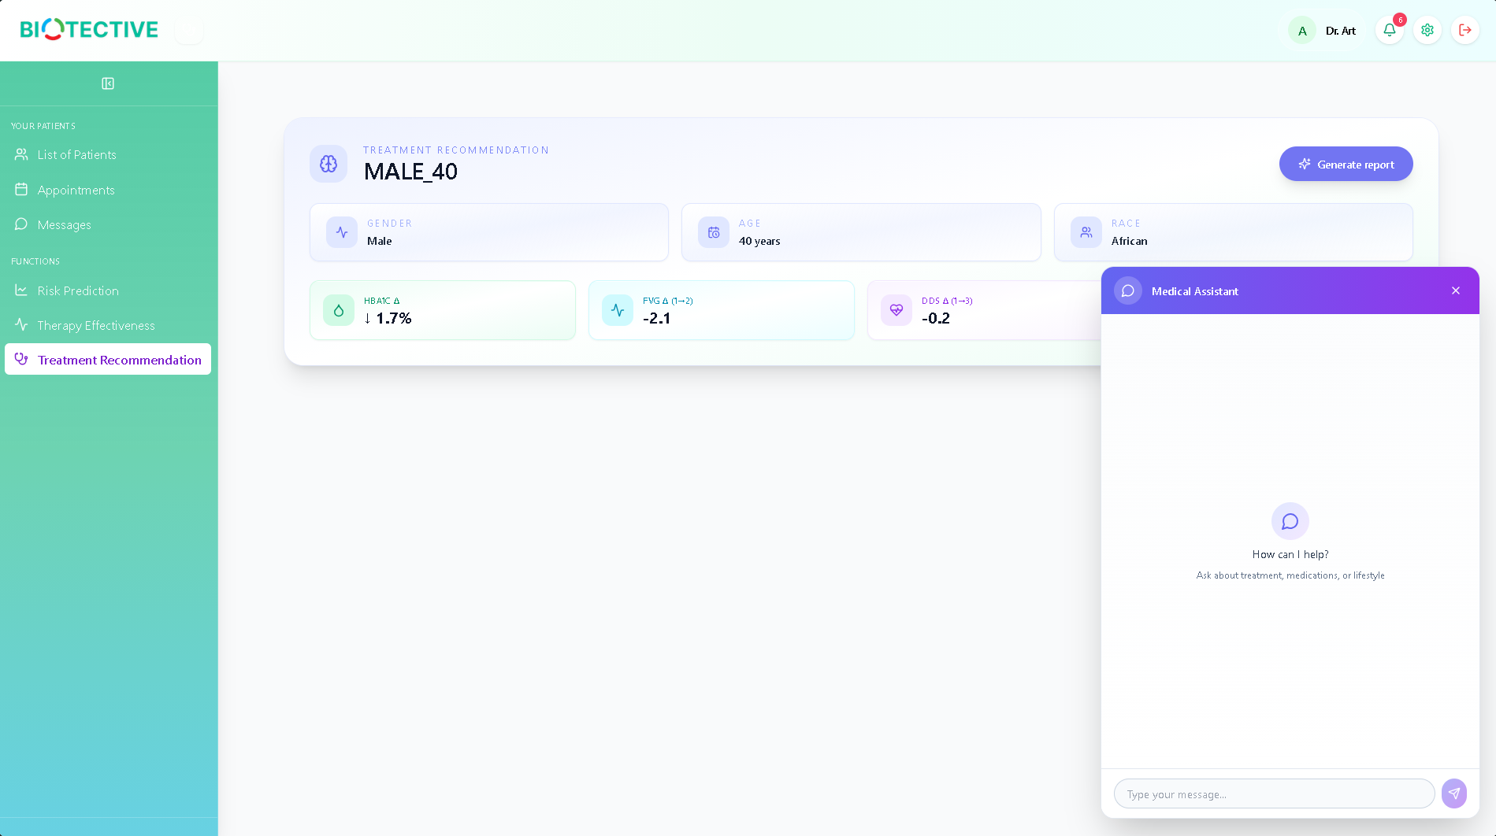
Steps:
- From patient profile, click Treatment Recommendation
- Or navigate to Treatment Recommendation from sidebar
- Select a patient from the dropdown
- Click Generate Report
Report Sections:
1. Clinical Trend Analysis
- Recent HbA1c and FVG trends
- Comparison across visits
- Trajectory interpretation
2. Risk Interpretation
- Health risk assessment
- Breakdown by category:
  - Complication Risk - Overall diabetes complications
  - Kidney Function - eGFR and UACR analysis
  - Adherence - Treatment compliance indicators
3. Medication Plan
- Current insulin regimen review
- Suggested medication adjustments
- Dosage recommendations
- Evidence-based alternatives
4. Lifestyle & Diet Advice
- Overall Summary - Patient’s current situation
- Lifestyle Recommendations:
  - Physical activity guidelines
  - Sleep recommendations
  - Alcohol/smoking cessation
  - Stress management techniques
- Diet Recommendations:
  - Carbohydrate management
  - Fiber intake
  - Sodium restrictions
  - Protein requirements
  - Hydration goals
5. Outcome Forecast
- Predicted outcomes if current trends continue
- Expected improvements with recommendations
- Timeline for reassessment
Interactive Chat:
- Ask follow-up questions about the report
- Request clarification on recommendations
- Explore alternative treatment options
- Type questions in the chat box at the bottom
Tips:
- Review the full report before discussing with patient
- Use the chat feature to explore specific concerns
- Print or save the report for patient records
- Update treatment plan based on recommendations

Appointments
Manage patient appointments
📸 SCREENSHOT 31: Appointments Calendar
Show: Calendar view with appointments
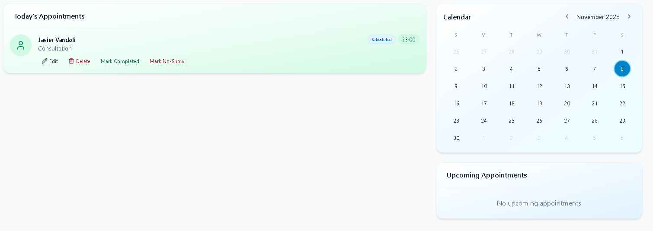
📸 SCREENSHOT 32: Create Appointment Modal
Show: New appointment form
and schedules.
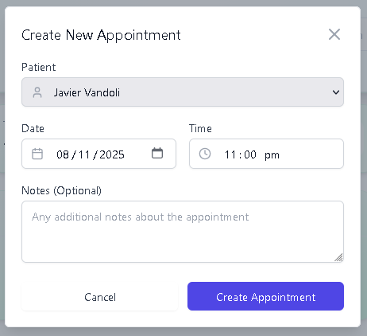
Steps:
- Click Appointments in the sidebar
- View calendar with scheduled appointments
- Click + New Appointment to create
Creating Appointments:
- Click + New Appointment
- Fill in the form:
  - Select patient from dropdown
  - Choose date and time
  - Select appointment type (Consultation, Follow-up, Lab Work, etc.)
  - Add notes (optional)
- Click Create Appointment
Managing Appointments:
- View - Click on appointment to see details
- Edit - Modify date, time, or notes
- Delete - Cancel appointment
- Filter - View by date range or patient
Calendar Features:
- Navigate months using arrow buttons
- Today’s date is highlighted
- Appointments shown on calendar dates
- Color-coded by appointment type

Messages
Communicate with your patients
📸 SCREENSHOT 33: Doctor Messages List
Show: Conversation list with unread badges
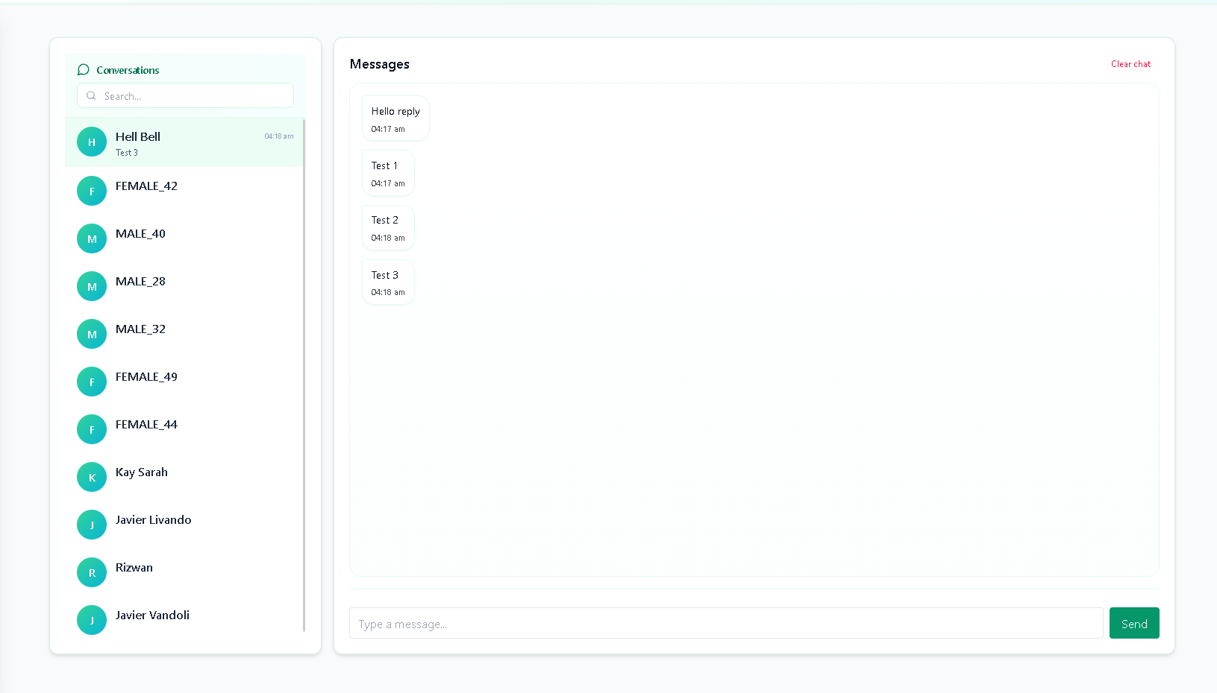
Steps:
- Click Messages in the sidebar
- View list of patient conversations
- Unread messages are highlighted
- Click on a patient to open conversation thread
- Type message and click Send
Features:
- Real-time messaging
- Notification badges for unread messages
- Search conversations by patient name
- Message history preserved
- Secure and HIPAA-compliant
Best Practices:
- Respond to patient messages within 24 hours
- Keep messages professional and clear
- Document important conversations in patient records
- Use for non-urgent communications only

Settings
Manage your doctor account
📸 SCREENSHOT 35: Doctor Settings
Show: Settings page with profile and notification options
settings.
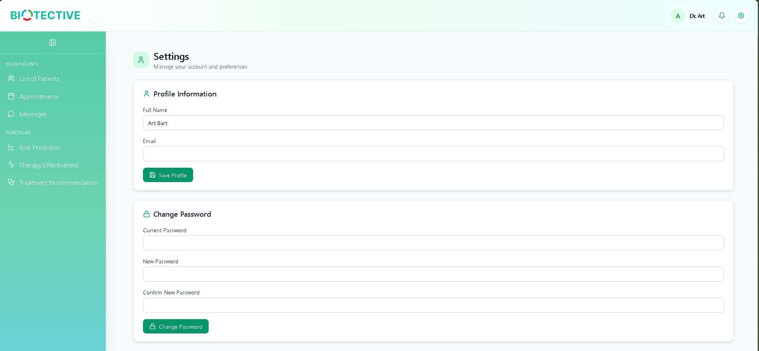
Steps:
- Click the Settings icon in the top-right
- Update your information:
  - Name
  - Email
  - Password
  - Notification preferences
  - Practice information
- Click Save Changes

Admin User Guide

Admin Dashboard
📸 SCREENSHOT 36: Admin Dashboard
Show: Admin dashboard with user statistics
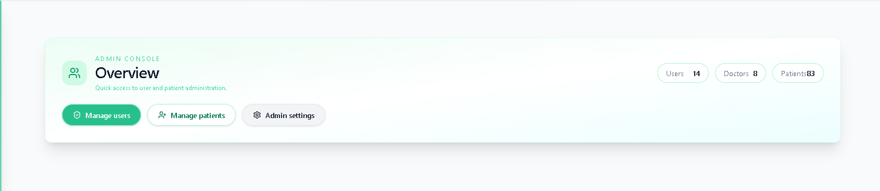
Central hub for system administration and oversight.
Features:
- Total user count
- System statistics
- Recent activity log
- Quick access to admin functions

Manage Users
Create, edit, and delete user accounts
📸 SCREENSHOT 37: Manage Users Page
Show: User list with search, filters, and actions
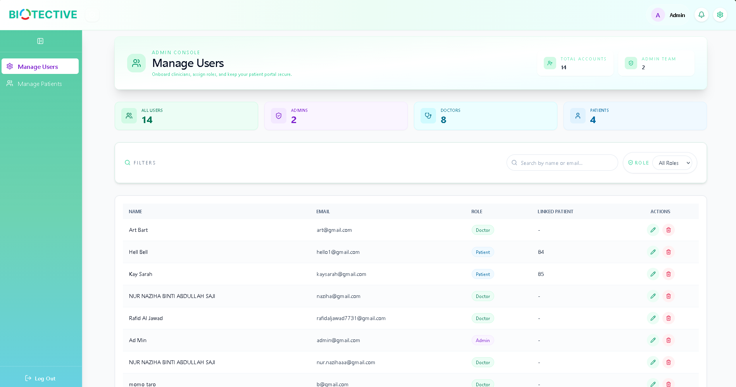
📸 SCREENSHOT 39: Edit User Page
Show: Edit user form
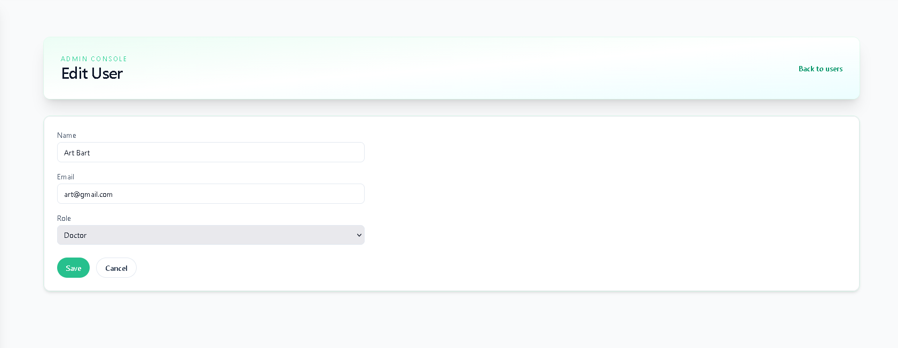
📸 SCREENSHOT 40: User Role Badges
Show: Admin (purple), Doctor (green), Patient (blue) badges
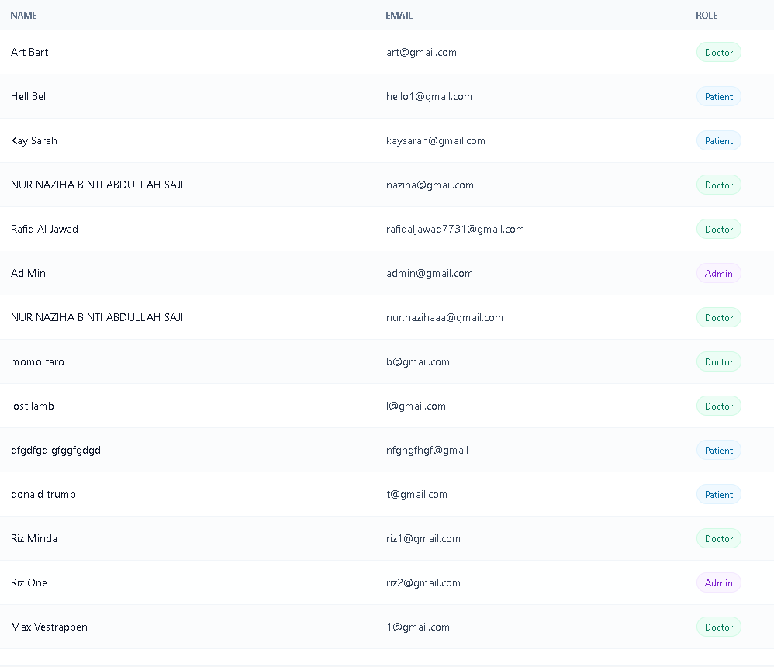

Steps:
- Click Manage Users in the sidebar
- View all users in the system
- Use search bar to find specific users
- Filter by role (Admin, Doctor, Patient)
Creating New Users:
- Click + Add User
- Fill in user information:
  - Name
  - Email
  - Password
  - Role (Admin/Doctor/Patient)
- Click Create User
Editing Users:
- Click the Edit icon next to a user
- Modify user information
- Click Update User
Deleting Users:
- Click the Delete icon next to a user
- Confirm deletion
- User is permanently removed
User Table Columns:
- Name
- Email
- Role (with color-coded badges)
- Created Date
- Actions (Edit, Delete)

Manage Patients
Oversee all patient records
📸 SCREENSHOT 41: Manage Patients Page
Show: Admin view of all patients with assigned doctor column
in the system.
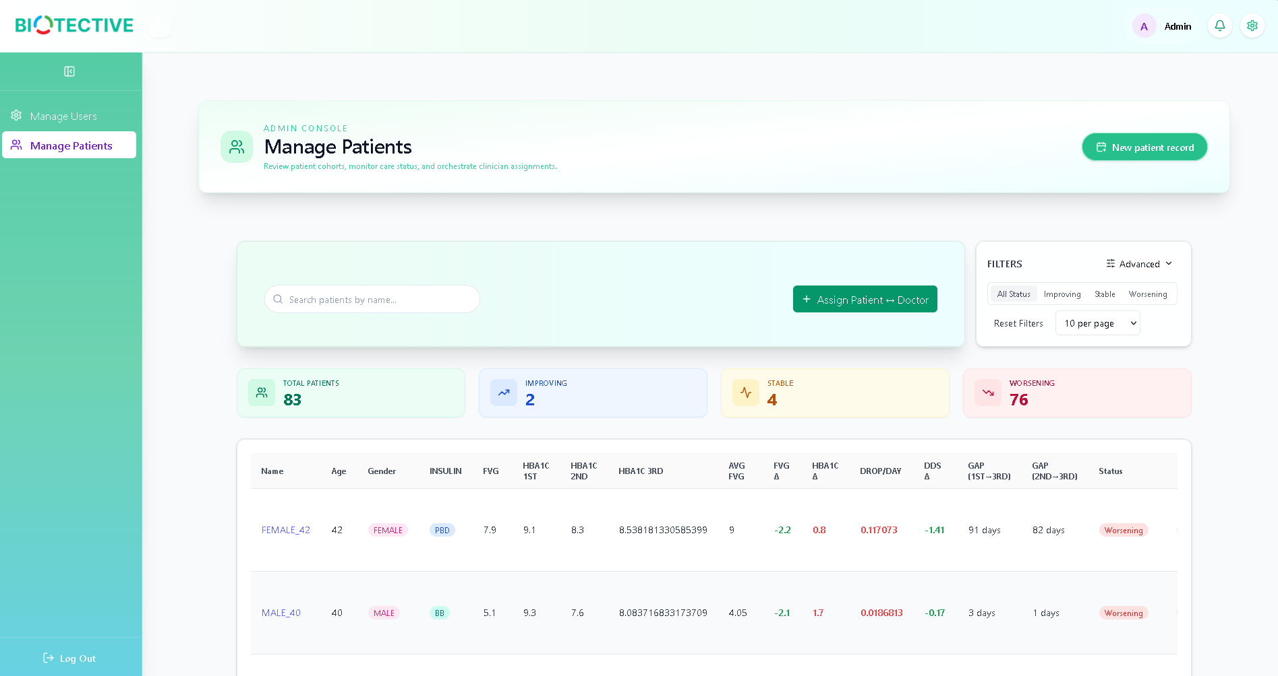
Steps:
- Click Manage Patients in the sidebar
- View all patients across all doctors
- Use filters and search to find patients
- See which doctor is assigned to each patient
Features:
- View all patients regardless of doctor assignment
- See assignment status (Assigned/Unassigned)
- Delete patient records
- Reassign patients to different doctors

Assign Patient ↔ Doctor
📸 SCREENSHOT 42: Assign Patient-Doctor Modal
Show: Assignment modal with patient and doctor dropdowns
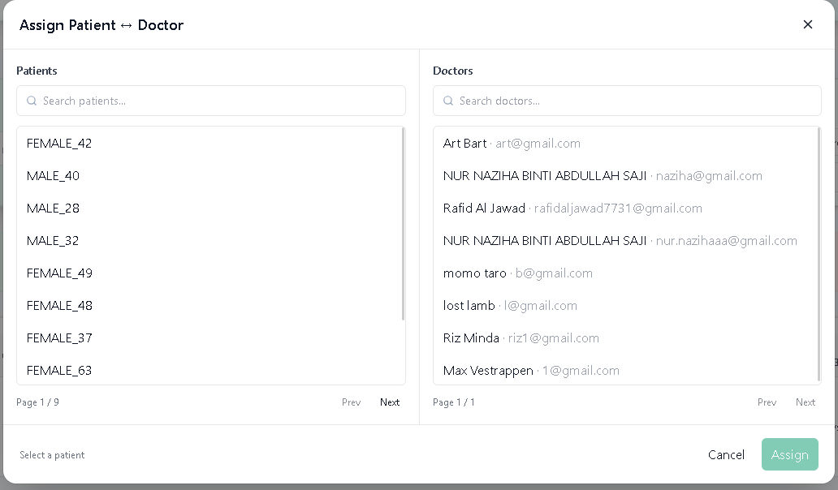
Link patients with their healthcare providers.
Steps:
- Click + Assign Patient ↔ Doctor button
- In the modal:
  - Select a patient from dropdown
  - Select a doctor from dropdown
- Click Assign
- The patient will now appear in the doctor’s patient list
Reassigning Patients:
- Use the same modal
- Select the patient
- Choose a different doctor
- Click Assign to update
Unassigning Patients:
- Select the patient
- Choose “Unassigned” from doctor dropdown
- Click Assign
Tips:
- Patients can only be assigned to one doctor at a time
- Doctors can have unlimited patients
- Unassigned patients won’t appear in any doctor’s list

Admin Settings
📸 SCREENSHOT 44: Admin Settings
Show: System settings page
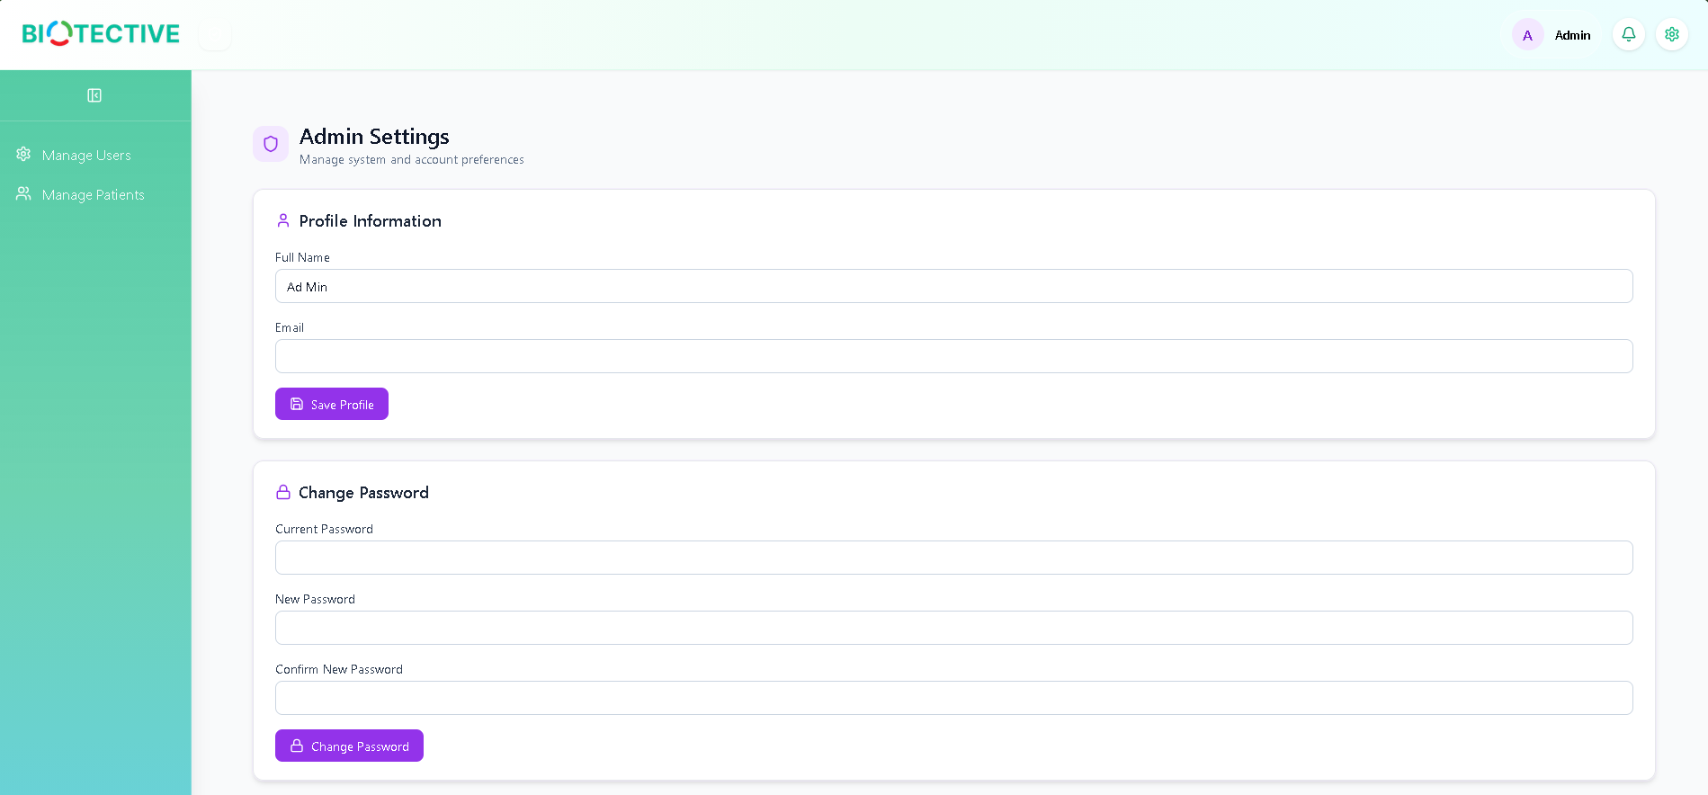
Configure system-wide settings.
Options:
- System preferences
- Security settings
- Notification configurations
- Backup and maintenance
- User role permissions

Common Features

Navigation
📸 SCREENSHOT 45: Sidebar Expanded
Show: Full sidebar with menu items
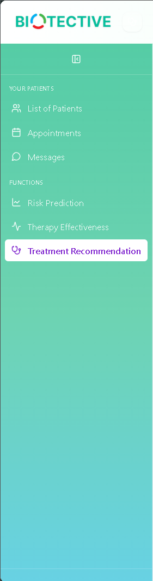
📸 SCREENSHOT 46: Sidebar Collapsed
Show: Collapsed sidebar with icons only

SCREENSHOT 47: Top Header Bar
Show: Header with logo, role badge, notification bell, settings
Sidebar Menu:
- Collapsible sidebar (click arrow icon to collapse/expand)
- Role-specific menu items
- Active page highlighted
- Hover for tooltips when collapsed
Top Header:
- BIOTECTIVE logo (click to return to dashboard)
- Role badge showing your current role
- Notification bell (shows unread count)
- Settings icon
- User profile indicator

Notifications
📸 SCREENSHOT 48: Notification Dropdown
Show: Notification panel with unread count and items
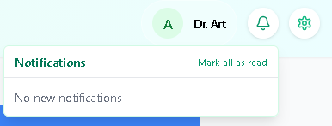
Bell Icon (Top Right):
- Click the bell icon to view notifications
- Notifications include:
  - New messages from patients/doctors
  - Appointment reminders
  - System updates
- Click on a notification to navigate to relevant page
- Click “Mark all as read” to clear notifications
Notification Types:
- 🔵 New message received
- 📅 Upcoming appointment
- ⚠️ System alert

Search Functionality
📸 SCREENSHOT 49: Search Functionality
Show: Search in action with filtered results
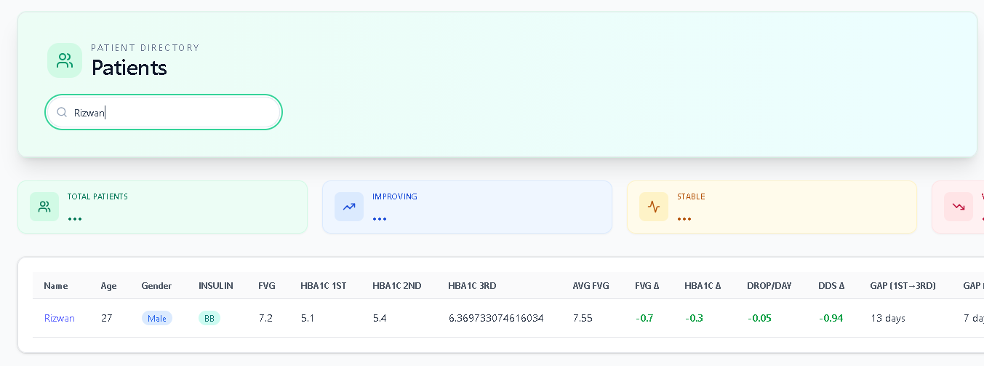
Most list views include search capabilities:
- Type in the search box
- Results filter in real-time
- Search typically covers names and key identifiers
- Clear search to see all results

Filters
📸 SCREENSHOT 50: Filter Options
Show: Multiple filters applied
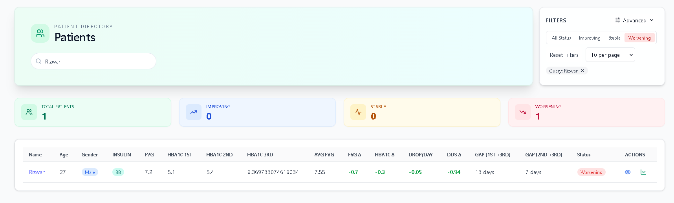
Advanced filtering options available on list pages:
- Click filter dropdowns
- Select criteria
- Apply multiple filters simultaneously
- Click “Reset Filters” to clear all

Sorting
📸 SCREENSHOT 51: Table Sorting
Show: Table with sort indicators
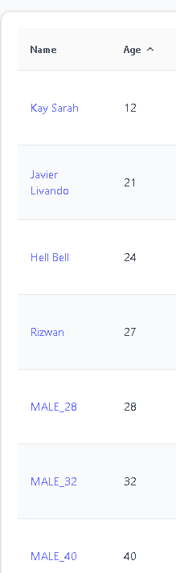
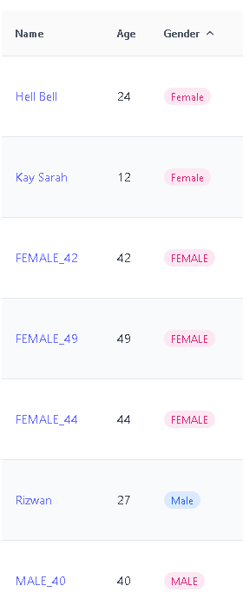
Click column headers to sort tables:
- First click: Sort ascending (A-Z, 0-9)
- Second click: Sort descending (Z-A, 9-0)
- Arrow icon indicates current sort direction

Pagination
📸 SCREENSHOT 52: Pagination Controls
Show: Pagination with page numbers and per-page dropdown
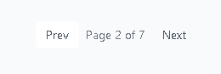
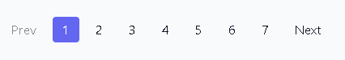
Navigate large datasets:
- Use “Prev” and “Next” buttons
- Click page numbers to jump to specific page
- Adjust “per page” dropdown to show more/fewer items

Logout
Steps:
- Click Log Out button at bottom of sidebar
- You’ll be returned to the login page
- Your session is securely ended

Troubleshooting
1. Cannot Log In
- Solution:
  - Verify email and password are correct
  - Check Caps Lock is off
  - Clear browser cache and cookies
  - Try password reset if available
  - Contact system administrator
2. Page Not Loading
- Solution:
  - Check internet connection
  - Refresh the page (F5 or Ctrl+R)
  - Clear browser cache
  - Try a different browser
  - Check if system is under maintenance
3. Risk Prediction Not Working
- Solution:
  - Ensure patient has complete data for visits 1 and 2
  - Required fields: HbA1c (1st, 2nd), FVG (1st, 2nd)
  - Click “Recalculate” to force fresh prediction
  - Contact support if issue persists
4. Therapy Effectiveness Shows Error
- Solution:
  - Patient needs at least 3 visits with complete data
  - Required: HbA1c, FVG, DDS for all 3 visits
  - BMI, blood pressure, kidney function data needed
  - Complete missing fields in patient profile
5. Treatment Recommendation Not Generating
- Solution:
  - Ensure patient has sufficient clinical data
  - Check internet connection (requires external AI service)
  - Wait for report generation (may take 30-60 seconds)
  - Try again if timeout occurs
6. Messages Not Sending
- Solution:
  - Check internet connection
  - Verify recipient is assigned (for doctors)
  - Refresh the page
  - Message may be delayed - check again in a few minutes
7. Cannot See Patients (Doctor)
- Solution:
  - Verify patients are assigned to you
  - Check filters aren’t excluding patients
  - Clear search box
  - Contact admin to assign patients
8. Notifications Not Showing
- Solution:
  - Enable browser notifications
  - Check notification settings in your profile
  - Refresh the page
  - Clear browser cache

Browser Compatibility
Recommended Browsers:
- ✅ Google Chrome (latest)
- ✅ Mozilla Firefox (latest)
- ✅ Safari (latest)
- ✅ Microsoft Edge (latest)
Not Recommended:
- ❌ Internet Explorer (any version)
- ❌ Outdated browser versions

Performance Tips
- Use recommended browsers for best performance
- Close unused tabs to free up memory
- Clear cache regularly (weekly recommended)
- Stable internet connection (minimum 5 Mbps recommended)
- Avoid multiple simultaneous sessions on same account

Glossary
HbA1c - Hemoglobin A1c, measures average blood glucose over 2-3 months
FVG - Fasting Venous Glucose, blood sugar level after fasting
DDS - Diabetes Distress Scale, measures emotional burden of diabetes
BMI - Body Mass Index, weight-to-height ratio
eGFR - Estimated Glomerular Filtration Rate, kidney function indicator
UACR - Urine Albumin-to-Creatinine Ratio, kidney damage indicator
SBP/DBP - Systolic/Diastolic Blood Pressure
RAG - Retrieval-Augmented Generation, AI technique using external knowledge
Insulin Regimens:
- Basal - Long-acting background insulin
- Bolus - Rapid-acting mealtime insulin
- PBD - Premixed Biphasic Daily
- BB - Basal-Bolus combination
- PTDS - Premixed Twice Daily Split

End of User Manual
This manual is intended for authorized users of the BIOTECTIVE system. All patient data is confidential and protected under applicable healthcare privacy regulations.

